Annual Report 2021/22

Report of the Trustees for Annual General Meeting
to be held on 21 November 2022

Glasgow Children’s Holiday Scheme – 2021/22

The Trustees are pleased to present their report together with the accounts of the charity for the year ended 31 March 2022.

Who we are and what we do

Holidays, for most of us, offer an escape to new horizons, fun and adventure.

For many families, however, holidays are out of reach. Twenty per cent of Glasgow’s population is income deprived. A third of all children in Glasgow are estimated to be living in poverty - that is 36,000 children - many of whom may never enjoy a few days at the seaside or in the countryside.

For more than 60 years, Glasgow Children’s Holiday Scheme (GCHS) has provided holidays for thousands of disadvantaged children and their families, making memories. Each year, GCHS aims to organise holidays for over 500 children and young people from Greater Glasgow - the chance to enjoy a holiday away from the stresses of daily life is something that many of us take for granted, but many children have never or rarely had the chance to experience.

GCHS is established for charitable purposes only. In terms of charitable purposes set out in the Charities and Trustee Investment (Scotland) Act 2005, the main purpose is ‘the relief of those in need by reason of age, ill-health, disability, financial hardship or other disadvantage’.

The Holiday Scheme’s objectives are:

- To provide holidays and short breaks for children, families and carers who otherwise would not access a holiday due to disadvantages by reason of poverty, deprivation, ill-health, disability or other adverse circumstances
- To enable access to days out and activities for disadvantaged children, families, carers and organised groups of young people
- To support youth organisations to access activity-based breaks for groups of young people
- To promote at local, regional and national level the need and benefits of holidays and breaks for children, carers and families

The charity operates across the Greater Glasgow area. The charity is committed to equality and diversity and to ensure that all service users and applicants are treated equitably regardless of sex, gender, race or disability or any other protected characteristic.
The Holiday Scheme reviewed and updated its key objectives in November 2021 following the decision to cease host holidays and instead to develop family access to days out and young people’s access to activities.

Through those objectives we provide opportunities for a break, a holiday, a day out or an activity that families, children and young people would not otherwise get.

Together, let’s make memories and give children a break.

Chair’s Report

I am pleased to present the annual report for the Holiday Scheme for 2021/22.

The start of our 2021 season remained affected by Covid restrictions meaning we could not open in March. We welcomed our first families in April but then had to halt bookings as lockdown and changing levels of restrictions stopped our Glasgow families from travelling. We began to welcome families again in June and successfully had a full summer, which was much needed by families affected by lockdown and Covid’s wider implications. Due to government restrictions, we were unable to facilitate any youth group breaks.

As a charity we rely entirely on grants and donations. We appreciate the continued support we have enjoyed from volunteers, our regular donors and all who continue to award grants and funding to us. In particular, we value the continued volunteer support in 2021/22 from Accenture, Virgin Money and EDF Energy. We also acknowledge the ongoing support from a number of local churches, especially for our Christmas Gift Scheme.

We continue to benefit from the generous legacy funding received through the Michael Janson Revocable Trust. This was a legacy received from Michael and Varuni Janson. Following their death, the Holiday Scheme was one of 8 charities in receipt of a legacy donation which has been invested for the longer-term sustainability of the charity as well as to support our ongoing running costs. We remain hugely grateful.

We again fully prepared our caravans in advance of the 2021 season ensuring we maintain the highest standards of accommodation. We were delighted to also be able to upgrade our oldest caravan for a new caravan.

In terms of 2022/23, we hope to see a ‘near to normal’ year and plan to:

  - Continue to ensure our caravans are of the highest standard
  - Continue to purchase additional caravan capacity for peak school holiday periods
  - Support the return of youth groups to our caravans for activity-based breaks
  - Develop the charity’s support to voluntary organisations to enable family days out, group days out and access to activities for young people
  - Review and improve our website information and social media presence through a University of Glasgow internship

In terms of governance, we continue to meet regularly as a committee of Trustees both online and in person. We acknowledge the commitment of each of our Trustees. We especially thank Graham Haugh for his contribution to the charity prior to his retiral as a Trustee in November 2021.

We recognise and value our 2 part-time members of staff and have enabled a hybrid mix of working both in the office and remotely.

Our holidays can help strengthen relationships within the family and give family members a fresh perspective, providing them with a break from the daily routine. Holidays allow children to have fun, enjoy new experiences and for the family to build happy memories. Our feedback shows what a difference a holiday can make. It is anticipated that demand will continue to be very high as we progress through the pandemic and living costs are also rising meaning holidays will be even further out of reach for many families.

As always, we appreciate and fully acknowledge the support we receive from everyone connected to the Holiday Scheme.

Thank you.

Dominic Young, Chair

Objectives and Aims

Glasgow Children’s Holiday Scheme
Achievements and Performance 2021/22
Our financial performance 2021/22 is detailed in our annual accounts.

In 2021, while we had no host family holidays or youth breaks, we enabled 127 families to get a holiday, including 259 children and young people and 269 adults. This included:

11 children with a physical disability
26 children had a learning disability
18 children with multiple care needs
16 children with sensory impairment
32 children on the autism spectrum
12 children identified as having school behavioural issues
26 children with additional educational needs
21 children affected by domestic violence
31 families affected by bereavement
48 adults/young people with mental health issues
16 families affected by drug/alcohol/substance misuse
16 adults with a disability (physical and/or learning)
64 pre-5 aged children
45 single parent families
10 young carers
20 kinship carers
3 asylum seeker families
14 families from minority ethnic groups

We were also able to support 73 families and 175 children and young people through our annual Christmas Gift Scheme.

We supported 200 young people to access football and receive goody bags through the Better Scotland Football Foundation.

We also ensured many families got a day out they otherwise would not be able to afford. We supported young people to access activities and provided organisations with support to improve outdoor play areas. We also, through funding from the STV Appeal, were able to provide direct support to families as part of their Winter Fund in partnership with Glasgow Women’s Aid, The Daisy Project, TASK child care, Ruchazie Pantry and Church House, Bridgeton.

We provided direct support to a few voluntary organisations to enable family days out and access to activities for groups of young people. One example was funding to Royston Youth Action for their Quality Time Trips project as noted below:

The quality time trips were devised as a result of a direct need from our children and young people. During lockdown and the pandemic, they all struggled emotionally and mentally and we wanted to spend quality time with a very small group of them out with the project setting and spend time doing a fun ‘treat’ activity, it gave us a chance to really chat to them about how they are feeling and chat about what is going on in their lives right now to see if the RYA team could help the families even further. We have been on trips to parks, bowling, cinema, out for lunches and dinners, soft play and had pamper afternoons etc. We will pick a trip that suits the child/young person and we also make sure they are fed on all of the trips. Parents and guardians can refer a child and they can also ask to go on a trip. Feedback from all those who have taken part, and their parents, has been so lovely and they have all said; “it has cheered them up, made them forgot about troubles for the day, gave their parents some respite, and helped them create fun new memories with their friends”.

Allocation of our caravan holidays are based on need and by matching the type of holiday to best meet individual and family needs. To ensure this we work together with our referral agencies (social work, schools and health) and various voluntary and charitable organisations throughout Glasgow with whom we have developed networks over the years.

In terms of governance, the management committee continued to meet regularly (online and in person) to ensure the effective governance and operation of the Holiday Scheme. We acknowledge the commitment of each of our Trustees. Trustees take due account of governance requirements either as a consequence of our own considerations or external advice, in particular, from OSCR. This included OSCR’s approval of our updated objectives. We successfully upgraded our ICT with improved flexible working and more efficient office broadband. Staff worked between home and office with appropriate ICT support.
We will continue to promote and work with partners to promote children and families getting access to holidays and breaks.
There is clear academic and other evidence of the benefits a holiday or break can provide, and the role they can play in enriching people’s lives, including impacts on mental health, wellbeing, happiness and overall quality of life. Studies of social tourism have demonstrated the benefits for children, families and adults of holidays and recognised the benefits people get in terms of respite, companionship and general health and wellbeing.
Glasgow remains the most deprived city and local authority area in Scotland. The following summary provides specific statistics for Glasgow:

47.3% of Glasgow residents reside in the 20% of most deprived areas in Scotland
34% of all children in the city were estimated to be living in poverty
24% of dependent children live in a household where at least one parent is disabled.

Levels of poverty in Glasgow are not likely to improve and are compounded by the effects of Covid restrictions, leaving the European Union, welfare reforms and cost of living challenges.

The Holiday Scheme will respond to those consequences by continuing to offer the opportunity of a break and holiday as well as look at ways to extend our provision through, for example, days away for children and families and additional rental caravans at peak holiday periods.

Caravan Holidays
In any one ‘normal’ year we help over 200 families, around 500 children and young people and over 400 adult parents/carers who all enjoy a break through the Holiday Scheme. Inevitably, 2021/22 did not see those numbers. Of the children, all are disadvantaged, many have a disability, some with multiple care needs and others have challenges such as learning difficulties or autism. We support a range of families including families affected by domestic violence, by bereavement, as well as young carers, kinship carers and single parents/carers.

In all cases they are families affected by poverty or disadvantage, who are on benefits or low incomes and who otherwise would generally not be able to afford any kind of break or holiday. A holiday can provide so many good memories and positive experiences for children and their families helping them to deal better with day-to-day challenges when they come home. We continue to be oversubscribed by applications each year, in particular, for the school holiday periods but manage that effectively year to year.

When funding allows, we rent additional caravan capacity at those peak holiday periods enabling us to support more children and families. Caravan holiday applications are accepted all year round but we encourage they be received as early as possible in the calendar year to provide a higher chance of getting a break.

We continue to keep direct holiday costs as low as possible for families charging only £20-£40 depending on length of break. A family holiday though is not dependent on receipt of the fee. This charge allows us to partly cover our weekly cleaning and changeover costs and is kept under review but the charity is focused on keeping any direct costs low.

Host Family Holidays
Since its inception, the Holiday Scheme has enabled young people to experience the benefit of a holiday with a volunteer host family. This has been a successful and key part of the charity but in recent years the numbers participating has dwindled and the number of host families is very low. Accordingly, Trustees agreed to discontinue this provision from 2022. We have sent our most recent Hosts a recognition of the valuable role they provided. The impact of hosting was often significant, providing opportunities to young people that they otherwise would not have had and in some cases making lifelong connections and friendships.

Activity Based Breaks
We were delighted to be able to take bookings for youth group breaks with the first of those scheduled for April 2022 and further groups planned during 2022/23. Evidence shows that young people get a great benefit from these breaks confirming the worth and benefit of the few days away in a different environment. There is a focus on group activities, outdoor access and the chance to build positive relationships.

Christmas Gift Scheme
The Holiday Scheme also operates an annual Christmas gift scheme providing gifts and support to the children and families who we deal with and who need additional support around Christmas. Our Christmas Gift Scheme in 2021 enabled us to help 175 children and 73 families either with gifts and/or vouchers. We achieved this through the continued support of 4 local churches and with fantastic individual supporters.

Most referrals are for a family break, where we offer high standards of accommodation suitable for all age ranges and levels of disability to ensure accessibility is as wide as possible. We do this through building working relationships with colleagues already working closely with children and families in the statutory and voluntary sectors. By working together, we maximise the benefit to those in most need and ensure resources are spread as fairly as possible.

Evaluation of feedback from families and children who use the service will continue to inform plans for the future. We continue to develop our support to children and families. In this way, we help to ensure that service development is needs led.

The Impact of Holidays and Breaks through GCHS

Our 2021 Impact Report, prepared by an Internship through the University of Glasgow, considered there were 5 main impacts from our holidays and breaks identified by service users:
- The opportunity to strengthen families
- The potential to aid positive feelings
- The means to broaden experiences
- The capacity to help children being active
- The ability to develop social interactions and to reduce isolation

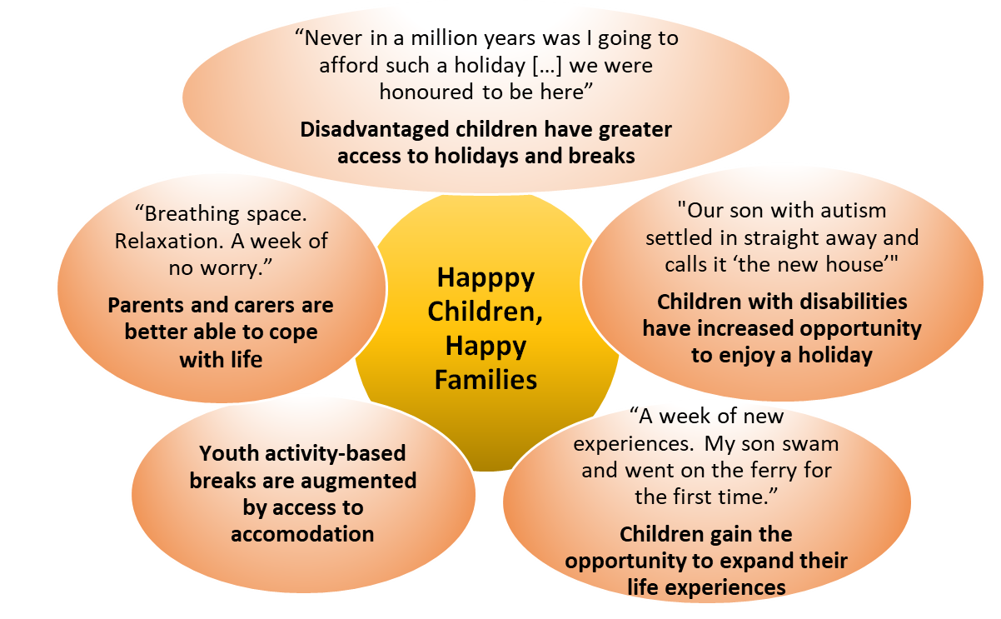
Strengthening Families
“Myself and husband and other 3 children find it hard to spend family time together but with GCHS it all changed.”
Feedback from families and children highlighted how, often for the first time in their lives, they had the opportunity to get a break and to spend quality time together away from their home environment. The chance to relax in the caravans, play outside or explore the surrounding area. Most families expressed that, due to their “every day stresses and struggles”, they had little if any time before the holiday to enjoy time together and build their relationships within their respective families.
Aiding Positive Feelings
“I am so excited and tears for joy are running down my cheeks”
Every family highlighted the myriad positive impacts their holiday brought to them – both to the children and to their parents or carers. Children told us they felt happy, energised and more confident as a result of their holiday at Wemyss Bay. Parents also expressed that they feel a huge difference in themselves as they are better able to cope with their everyday lives and that, for a while or the first time in a long time, they felt stress free, carefree and content.
Broadening Experiences
“I had lots of fun and lots of adventures”
Through their holidays, children and young people had the opportunity to participate in new activities never experienced before and to form memories which they will be happy to remember. In a safe environment, children are able to play outside, to explore and for many it can be their first chance to get to swim. Feedback tells us families just enjoy having time away together, to relax and play games; to eat out or try something new, to enjoy the seaside and of course….enjoy an ice cream!
Helping Children be Active
“After holiday my children are active and happy”
By providing a safe space through their holiday scheme GCHS not only supported children to be able to play outside and enjoy the fresh air and the freedom of running in a big park, but also provided children with other activities supporting their physical wellbeing. Children, amongst other things, learnt how to swim, had the opportunity to collect shells at the seaside and go on the ferry for the first time. These activities had a positive effect on both physical and mental wellbeing, influencing children’s behaviour and welfare beyond their holiday at Wemyss Bay.
Developing Social Interactions and Reducing Isolation
“I can’t believe how much [my child] shines!”
Holidays and activity breaks supported children to engage in social interactions and therefore to reduce their isolation experienced as a result of their adverse life circumstances. Children reported that they made new friends during their holidays and often played together during their stay. These interactions supported children to feel part of the community and develop their interpersonal skills as well.

What Children and Families Said – Making Memories 2021

- We have all had a fantastic holiday. Lots of laughter. Coming home with a lifetime of happy memories. Thank you so much.

- The kids loved the holiday. They really enjoyed escaping the house and getting out for a change. I think they managed to forget about the hardship and difficulties of the last year during the holiday and this was priceless. They went to Largs and picked a lot of "special stones" from down at the water and tried the hot donuts and Nutella which went down a treat. Thank you.

- We would like to thank you so much for making it possible for us to have a wee break away to your caravan in Wemyss Bay. We are so very grateful and had such an amazing time. The caravan itself was fantastic and its location within the park was perfect. A nice quiet spot where the children could get out to play safely on the surrounding grassy areas. My youngest daughter especially loved that she was able to go out the caravan door and play as she doesn't get to do that at home as we live in a flat, she was in her element and so happy whilst there. It was a brilliant opportunity. Thank you once again for arranging this memorable break for us.

- The break is exactly what we needed it has been absolutely amazing. Seeing [my daughter] giggle and laugh has been brilliant. Thanks so much for allowing us the opportunity to be here.

- A massive thank you from two very excited and exhausted boys. We had a wonderful time at Edinburgh Zoo. A trip we otherwise wouldn't have been able to afford. Thank you. It was an amazing day. Boys loved it!

- Thank you for the holiday we had an amazing week. The weans had a great time swimming and doing the activities in the venue and going on the ferry! The sun shone all week. Thank you again.

- It was just beautiful the scenery is stunning and I enjoyed very much having a cup of coffee in the morning on the decking looking out at the sea! The kids had a ball and are still exhausted as are we! What you do is really something special enabling families struggling to manage to get on holiday and create lasting lovely memories for their kids; it really has meant so much to me.

- My wee girl is having a ball and it’s doing her confidence the world of good.

Trustees Report

Directors and Trustees The Holiday Scheme is a small registered charity, operates a part-time office and is managed by a volunteer group of trustees. The Trustees who served during 2021/22 and since the year end are as follows:

Dominic Young Chair and Trustee since November 2016
Hilary Gibbs Trustee since 2007
John McDougall Trustee since 2011
Anne Naismith Trustee from September 2017
Nicola Meek Trustee since January 2019 and Vice Chair since November 2021
Graham Haugh Trustee since January 2019 and retired November 2021
Alan Forbes Trustee since August 2020
Elaine MacMahon Trustee from May 2021

Employees (part-time)
Douglas Wilson, Coordinator (20 hours per week)
Allison Rose Grady, Programme Officer (15 hours per week)

Patron Alex Norton

Structure, Governance and Management

Governing Document The organisation is a Scottish Charitable Incorporated Organisation (SCIO) as at March 2014 and is governed by the constitution as lodged with the Office of the Scottish Charity Regulator (OSCR) in the Scottish Charity Register (Reg. no SCO22654)

Recruitment and Appointment of Trustees The constitution allows for up to 11 volunteer committee members including the chair. New Trustees are appointed by the existing Trustees through the management committee.

Trustee Induction and Training All committee members complete Trustee declarations and are made aware of the Holiday Scheme’s policies and procedures. All Trustees and staff are members of the Protection of Vulnerable Groups (PVG) Scheme and take due account of guidance issued by OSCR to charity trustees. Our Trustee Induction Programme is kept under review and is responsive to individual Trustee’s needs in terms of their skills and experience.
Trustees and staff have the opportunity to attend a range of seminars and training events through, for example, Glasgow Council for Voluntary Service (GCVS) of which we are a member, OSCR and charity Trustees seminars. A schedule of training events undertaken is held and regularly reported to committee.
Risk Management Trustees have assessed the major risks to which the Charity is exposed, in particular those relating to the operations and finances of the charity, and are satisfied that systems are in place to mitigate exposure to major risks. Our risk register is regularly reviewed and is presented to committee approximately every 6 months for review and any updates.
Our policy and procedures are reviewed regularly, in particular, our Child Protection Policy and Procedures which are assessed annually.
Related Parties The charity is not connected to any other body.

Reserves Policy Trustees seek to retain a minimum of six months running costs. Based on anticipated expenditure this equates to approximately £40,000. The reserves are necessary for the ongoing fees, insurance and maintenance of our 5 static caravans as well as staffing and general office running costs. In presenting our accounts for 2021/22, it is considered that our reserves can be effectively managed through our investment fund.

Caravan valuation The estimated total trade or exchange value of our 5 static caravans is incorporated in our annual accounts. Part exchange values are generally higher than trade values. It has been our general policy to part exchange each of the caravans for newer models prior to 10 years old. We also have a general policy of undertaking internal caravan refits after 4-5 years usage. We currently own 5 static caravans, all centrally heated and double glazed and capable of accommodating groups and families of 6 to 8 people. We have a 2020 Willerby Richmond 2 bedroom adapted caravan, a 2012 Atlas Chorus 3 bedroom which was partially refitted in 2018, a 2015 ABI Oakley 3 bedroom, a 2017 ABI Trieste 3-bedroom caravan and our most recent purchase a 2021 Swift Loire 3-bedroom caravan. All are sited at Wemyss Bay Holiday Park. Our adapted caravan is wheelchair accessible and 2 other caravans have access ramps.

Apart from the often unaffordable cost of going on holiday, parents and carers tell us that they have not been able to find such suitable accommodation elsewhere. We continue to provide a selection of books, games and toys in each caravan for general use.
Financial Review
The Charity’s raised income for the year amounted to £51,898.
Expenditure was £75,458 (including £13,030 in caravan depreciation). This resulted in a total deficit of £23,560 received during this financial year.
We entered the financial year with funds of £562,287 comprising £94,272 in cash at bank, £80 in petty cash, £949 in a deposit account, £400,319 in a charity investment fund and £66,667 in caravan fixed assets
The closing funds at the year-end were £571,528 comprising £39,455 in cash at bank, £421 in petty cash, £433,120 in our charity investment fund and £98,532 in caravan fixed assets.
Signed...................................................................... Date ……………………….
Dominic Young, Chair
Signed....................................................................... Date ……………………….
Nicola Meek, Vice Chair

Thank You

For funding and practical support during 2021/22 year we thank:

Michael and Varuni Janson | EDF Energy Helping Hands volunteer initiative | R Fraser
T Bannigan and Staff at Accenture | A Woodward and Virgin Money Foundation | Awards for All
All Saints Episcopal Church, Bearsden and Lunch Club and various individual members | WA Cargill Charitable Trust | The Commonweal Fund (towards additional caravan rental costs)
Arnold Clark Community Fund | J Semple | Better Scotland Football
Numerous Just Giving donations | B and I Davidson | The Trefoil Society (towards our adapted caravan costs)
Charities Aid Foundation | Glasgow Care Foundation (towards additional caravan rental costs) | Amazon Smile
Ruchazie Pantry | The Ryvoan Trust (towards youth group breaks) | St Andrew’s Church, Uddingston and various individual members
OLA Football Club | Kilt Walk | ALA Charitable Trust
Spurgin Charitable Trust | St Ninian’s Episcopal Church, Pollokshields, Glasgow and various individual members | The STV Appeal
Mrs Jane Allan’s Trust | Garfield Weston Foundation (towards new replacement caravan) | Saints and Sinners Club of Scotland
A Caldwell | St Margaret’s Church, Newlands, Glasgow and various individual members | Glasgow/Galloway Diocese Mothers’  Union
A MacLeod | E Hannah | H MacGilp
We also wish to thank a number of individual volunteers and donors for their support

As ever we say a huge thank you to our many volunteers, on behalf of all the children and families who have had a memorable experience this year. Support includes having fundraising events, helping to prepare the caravans, providing toys, books, games and kitchen appliances for our caravans, donating to our Christmas Gift Scheme, and giving through private donations. The Holiday Scheme couldn’t run without you.

How to help us

Glasgow Children’s Holiday Scheme only operates through donations and grant funding. Please continue to help us to give disadvantaged children the chance to create some happy holiday memories. Holidays matter and you can help give the chance for children to enjoy a break away from the stresses of daily life, something many of us take for granted but which many children have never have the chance to enjoy.
We are a small charity but we have a big impact and provide positive change:

- £10 can provide games and toys for one of our caravans
- £50 can help pay for a family holiday
- £100 can assist a youth group to get an activity break
- £5,000 can pay for the siting and maintenance of one of our caravans for a year enabling 90 children to get a holiday.

The Holiday Scheme relies on volunteers. If you can help us in any way please get in touch. We would be delighted to hear from you.
Please donate at: www.glasgowchildrensholidayscheme.org.uk
Contact:
Follow us on Twitter at @GCHS_charity | Suite 114, Pentagon Centre, 36 Washington St, Glasgow  G3 8AZ Tel 0141 248 7255  Email: admin@glasgowchildrensholidayscheme.org.uk  Website: www.glasgowchildrensholidayscheme.org.uk

Enjoy the views at Wemyss Bay and relax at one of our caravans…
Enjoy an ice cream Have fun at the outdoor play area
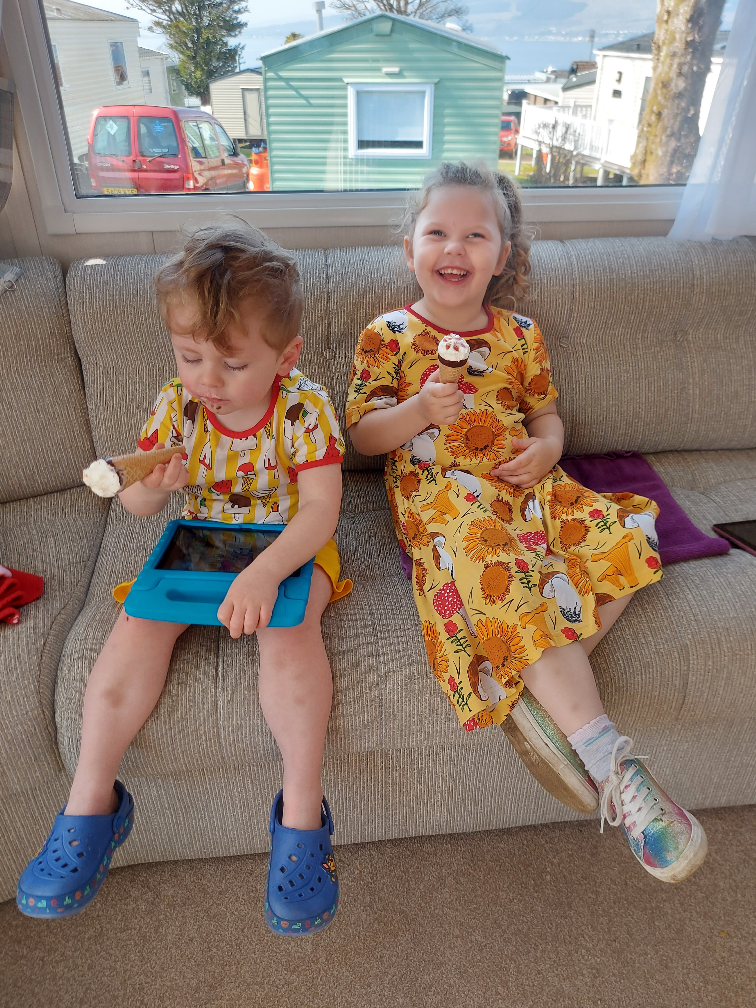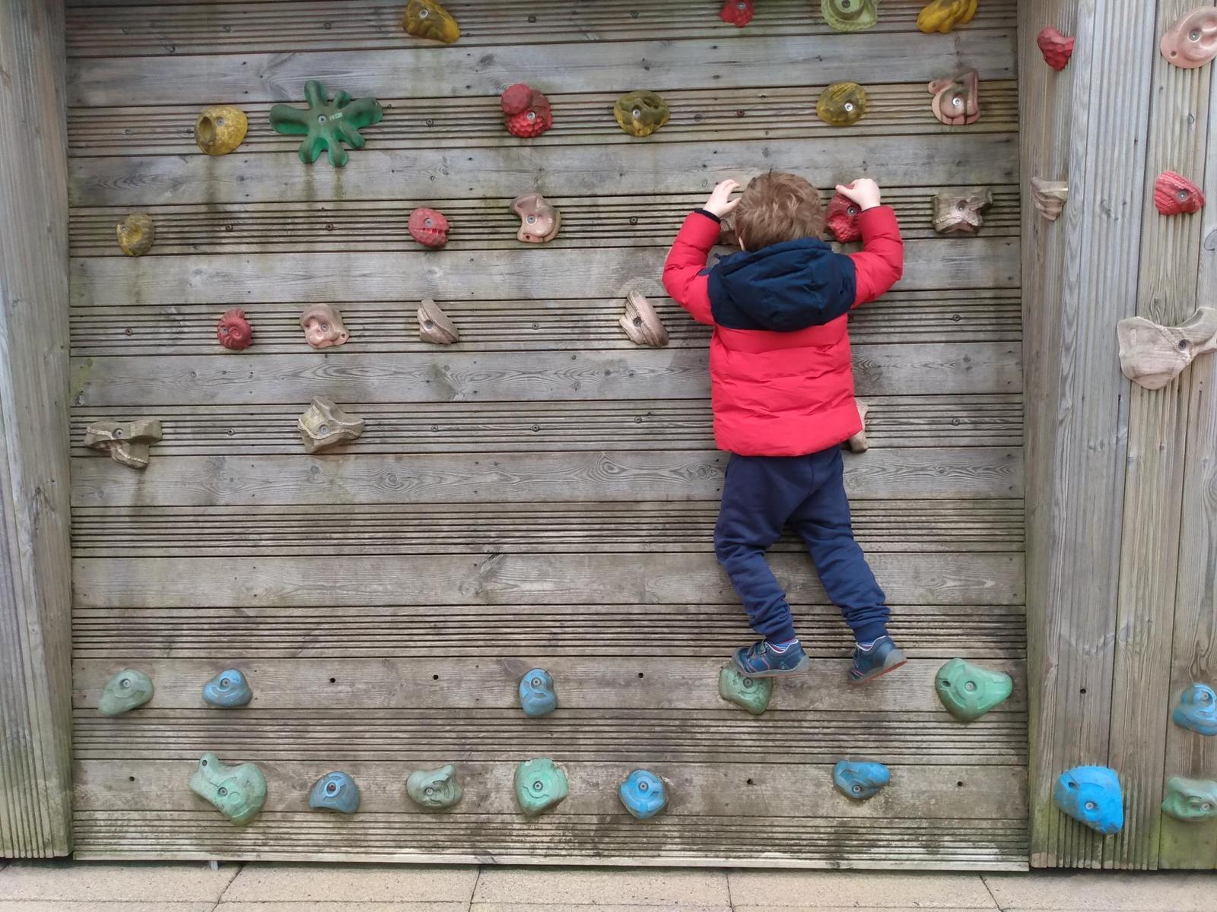
Enjoy the on-site entertainment  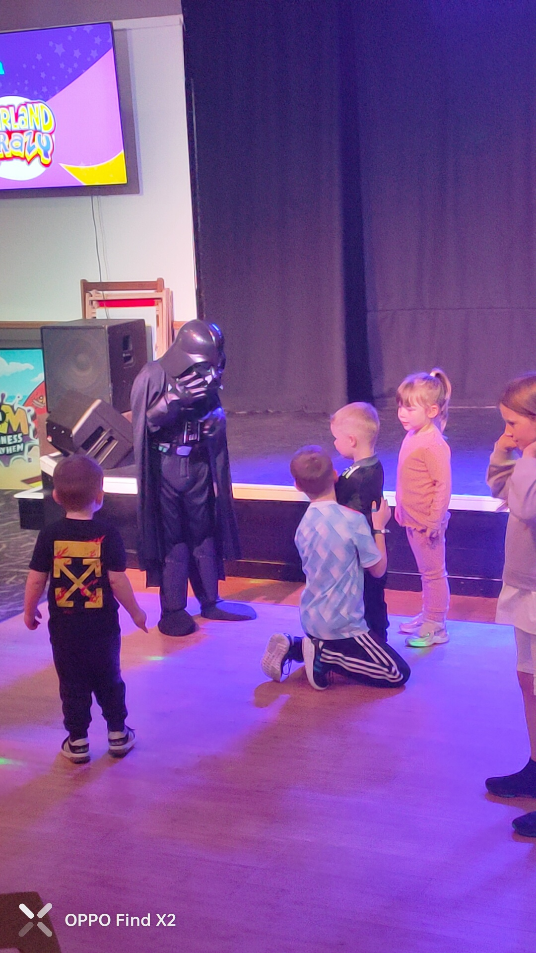 | Enjoy a youth activity break  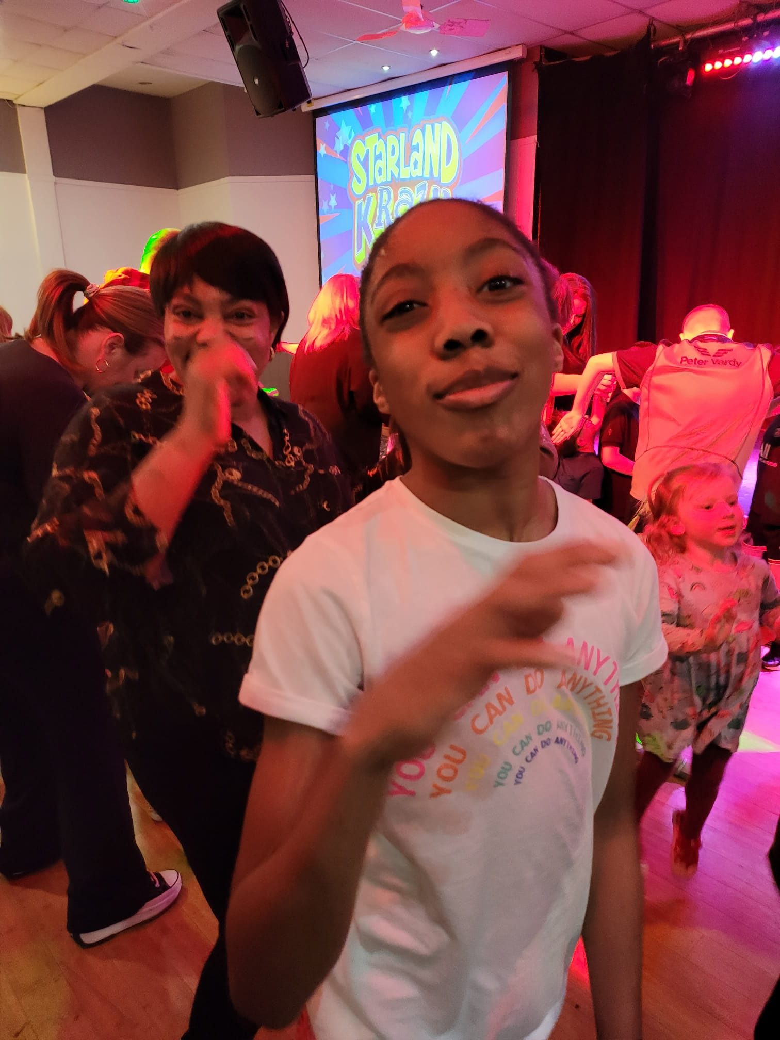
Have fun at the entertainment venue Enjoy the heated indoor pool
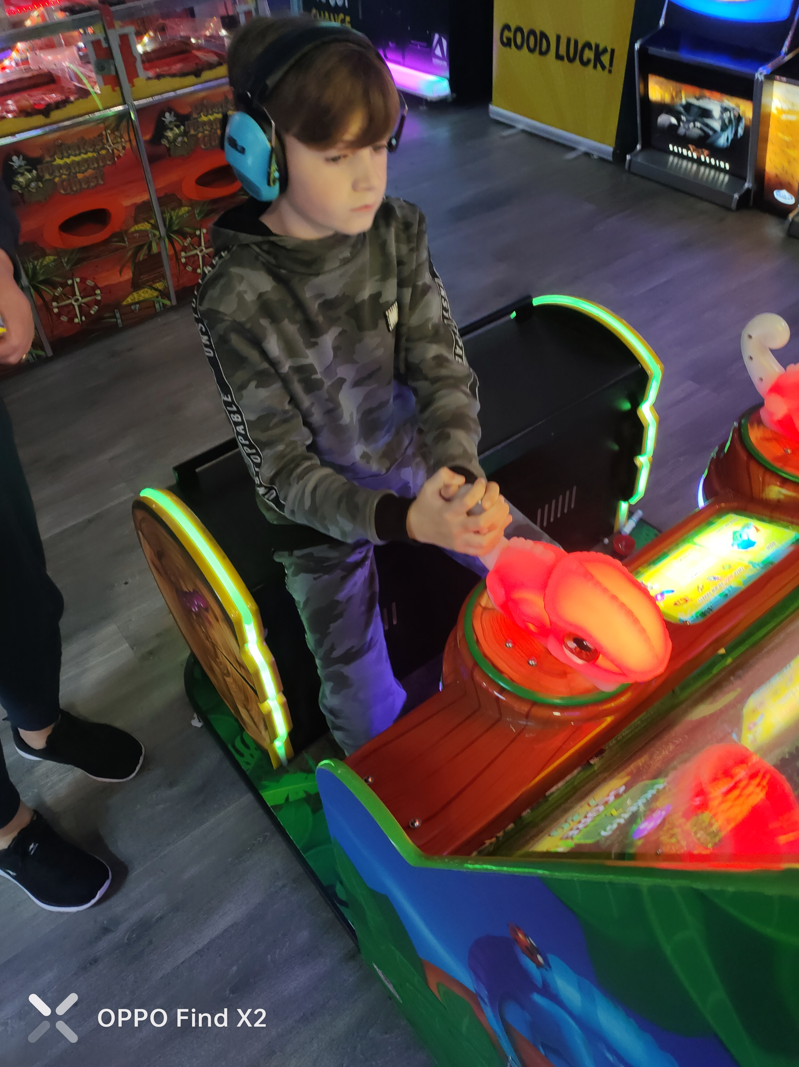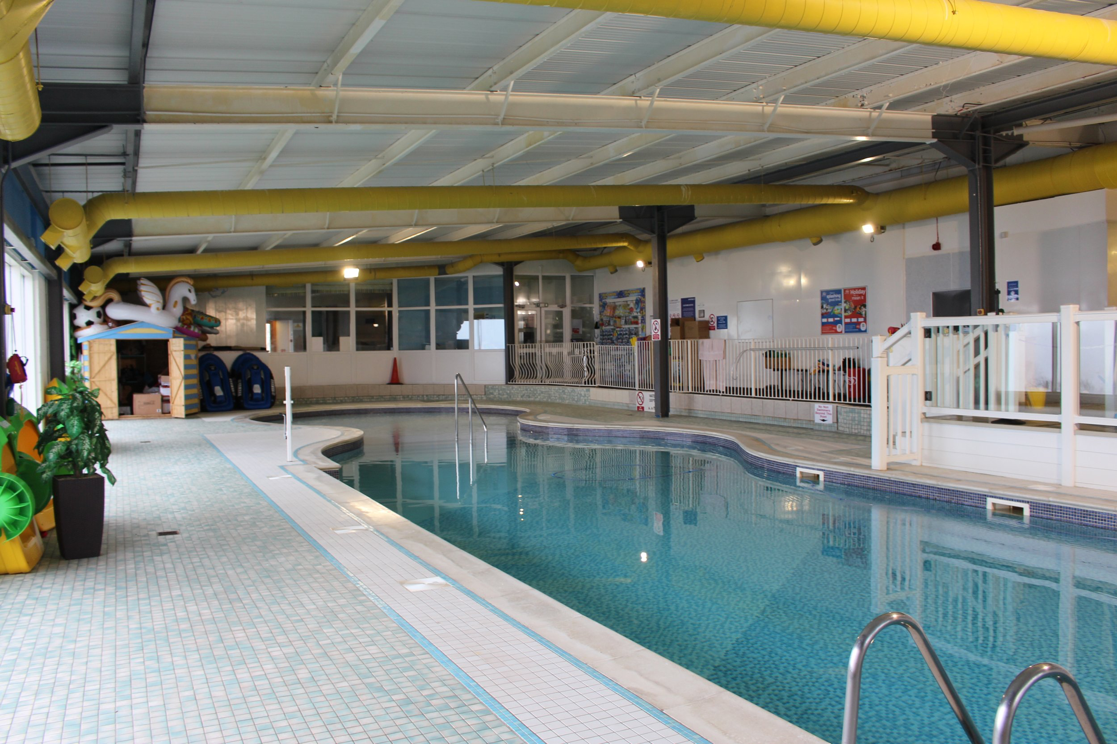

MAKING MEMORIES WITH GLASGOW CHILDREN’S HOLIDAY SCHEME
www.glasgowchildrensholidayscheme.org.uk
Twitter @GCHS_charity

