Annual Report 2022/23

Report of the Trustees for Annual General Meeting
to be held on 20 November 2023

Glasgow Children’s Holiday Scheme – 2022/23

The Trustees are pleased to present their report together with the accounts of the charity for the year ended 31 March 2023.

Who we are and what we do

Holidays, for most of us, offer an escape to new horizons, fun and adventure.

For many families, however, holidays are out of reach. Twenty per cent of Glasgow’s population is income deprived. A third of all children in Glasgow are estimated to be living in poverty - that is 36,000 children - many of whom may never enjoy a few days at the seaside or in the countryside.

For nearly 70 years, Glasgow Children’s Holiday Scheme (GCHS) has provided holidays for thousands of disadvantaged children and their families, making memories. Each year, GCHS aims to organise holidays for over 200 families and over 500 children and young people from Greater Glasgow. The chance to enjoy a break away from the stresses of daily life is something that many of us take for granted, but sadly many children have never or rarely had the chance to experience.

GCHS is established for charitable purposes only. In terms of charitable purposes set out in the Charities and Trustee Investment (Scotland) Act 2005, the main purpose is ‘the relief of those in need by reason of age, ill-health, disability, financial hardship or other disadvantage’.

The Holiday Scheme’s objectives are:

- To provide holidays and short breaks for children, families and carers who otherwise would not access a holiday due to disadvantages by reason of poverty, deprivation, ill-health, disability or other adverse circumstances
- To enable access to days out and activities for disadvantaged children, families, carers and organised groups of young people
- To support youth organisations to access activity-based breaks for groups of young people
- To promote at local, regional and national level the need and benefits of holidays and breaks for children, carers and families

The charity operates across the Greater Glasgow area. The charity is committed to equality and diversity and to ensure that all service users and applicants are treated equitably regardless of sex, gender, race or disability or any other protected characteristic.

Through those objectives we provide opportunities for a break, a holiday, a day out or an activity that families, children and young people would not otherwise get.

Together, let’s make memories and give children a break.

Chair’s Report

I am pleased to present the annual report for the Holiday Scheme for 2022/23 which saw a welcome return to a full year of uninhibited breaks for children and families. It continues to be fantastic to see the hugely positive impact a break has for children and families.

As a charity we rely entirely on grants and donations. We appreciate the continued support from volunteers, our regular donors and all who provide funding. We recognise the continued volunteer support from Accenture, Virgin Money and EDF Energy as well as ongoing support from several local churches and Mother’s Union, especially for our Christmas Gift Scheme.

We continue to benefit from the generous legacy received from Michael and Varuni Janson. This has been invested for the longer-term sustainability of the charity as well as to support our annual costs. A plaque to celebrate this legacy is displayed at our adapted caravan.

In terms of governance, we continue to meet regularly as a committee of Trustees both online and in person. We acknowledge the commitment of each of our Trustees.

Sadly, however, the start of 2023 saw the death of 2 great supporters of GCHS:

- Hilary Gibbs was a long-standing Trustee and former Chair. Hilary’s death was a huge shock to everyone, and we are so grateful for her fabulous commitment and contribution. We intend to celebrate Hilary’s contribution by naming our family support fund in her memory as well as mark Hilary’s legacy at our caravans. We recognise the huge loss to Hilary’s family. Hilary was introduced to the Holiday scheme by her best Friend Carol Orr, who she had worked with for many years, and she immediately saw the value for the scheme that helped so many people and families. Her passion for understanding people and relationships ran through Hilary’s whole life, and her commitment to the Holiday scheme reflects that dedication. When Hilary was with you, whether you were family, friend, colleague or someone she supported at work or through volunteering, you knew she was fully present and interested in what you were saying and doing. She had such a positive impact on so many people throughout her life but would never think that she did anything out of the ordinary. Her husband, Steve, and her children Becci and Daniel chose this quote from A.A Milne that they feel speaks to Hilary’s impact on all around her. “If there is ever a tomorrow where we are not together, there is something you must always remember. You are braver than you believe, stronger than you seem and smarter than you think. But the most important part is, even if we are apart, I will always be with you.”
They can be assured her lasting memory will be recognised by Glasgow Children’s Holiday Scheme.
- Alva Caldwell was a former Trustee and volunteer. Alva made a huge contribution to GCHS right to the very end of her life. We recognise her contribution over many years and the fantastic story of her connection to the great opera singer, Luciano Pavarotti, is shared on our website. We will also continue to connect with St Ninian’s, Pollokshields, Glasgow in Alva’s memory.

We recognise and value our 2 part-time members of staff and have enabled a hybrid mix of working both in the office and remotely.

Our holidays can help strengthen family relationships providing a break from the daily routine. Holidays allow children to have fun, enjoy new experiences and for the family to build happy memories. Our feedback shows what a difference a holiday can make. Demand continues to be very high due to the legacy of the pandemic and the huge pressure on living costs meaning holidays remain out of reach for many families.

In terms of 2023/24, we plan to:
  - Ensure continued delivery of caravan holidays to over 200 families.
  - Continue to purchase additional caravan capacity for peak school holiday periods.
  - Enable youth groups to use our caravans for activity-based breaks.
  - Formalise the charity’s support to voluntary organisations to enable family days out, group days out and access to activities for young people.
  - Improve our online presence including short videos and testimonials.
  - Seek sponsorship support for our caravans.
We hugely appreciate the support to the Holiday Scheme. Thank You

Dominic Young, Chair
Glasgow Children’s Holiday Scheme

Achievements and Performance 2022/23

Our financial performance 2022/23 is detailed in our annual accounts.

In 2022, we enabled 209 families to get a caravan holiday, including 429 children and young people and 382 adults. This included:

19 children with a physical disability
38 children had a learning disability
27 children with multiple care needs
22 children with sensory impairment
65 children on the autism spectrum
27 children identified as having school behavioural issues
50 children with additional educational needs
35 children affected by domestic violence
40 families affected by bereavement
102 adults/young people with mental health issues
29 families affected by drug/alcohol/substance misuse
46 adults with a disability (physical and/or learning)
86 pre-5 aged children
89 single parent families
25 young carers
42 kinship carers
15 asylum seeker families
29 families from minority ethnic groups

We were also able to support 85 families and 232 children and young people through our annual Christmas Gift Scheme.

We supported nearly 400 young people to access football and receive goody bags through our partnership with Better Scotland Football.

We supported youth groups to have 4 weekends away with 33 young people benefitting and we facilitated a weekend retreat for women and children affected by domestic violence.

We helped individual groups to organise 5 separate group days out with over 100 children participating.

We enabled 40 families and more than 80 children to get a day out they otherwise could not afford including cinema trips and bowling.

Allocation of our caravan holidays are based on need where families have never or rarely had any type of break. We work together with our referral agencies (social work, schools and health) and various voluntary and charitable organisations throughout Glasgow with whom we have developed networks over the years to promote children and families getting access to holidays and breaks.

Academic and other evidence, not least our own holiday feedback, clearly demonstrate the benefits a break can provide, and the role they can play in enriching people’s lives, including
impacts on mental health, wellbeing, happiness, and overall quality of life. Studies of social tourism have demonstrated the positive impact for children, families and adults of holidays and recognised the benefits people get in terms of respite, companionship and general health and wellbeing.

Poverty Context
Glasgow remains the most deprived city and local authority area in Scotland.

The following summary provides specific statistics for Glasgow:

47.3% of Glasgow residents reside in the 20% of most deprived areas in Scotland
34% of all children in the city were estimated to be living in poverty
24% of dependent children live in a household where at least one parent is disabled

Levels of poverty in Glasgow are not likely to improve and are compounded by the effects of the Covid pandemic, leaving the European Union, welfare reforms and cost of living challenges.

The Holiday Scheme will respond to those consequences by continuing to offer the opportunity of a break and holiday as well as look at ways to extend our provision through, for example, days out for children and families and additional rental caravans at peak holiday periods.

Caravan Holidays
In any one year, we help over 200 families, around 500 children and young people and over 400 adult parents/carers to enjoy a break through the Holiday Scheme. We were delighted to support so many children and families during 2022/23.

Of the children, all are disadvantaged, many have a disability, some with multiple care needs and others have challenges such as learning difficulties or autism. We support a range of families including families affected by domestic violence, by bereavement, as well as young carers, kinship carers and single parents/carers.

In all cases, they are families affected by poverty or disadvantage, who are on benefits or low incomes and who otherwise would generally not be able to afford any kind of break or holiday. A holiday can provide so many good memories and positive experiences for children and their families helping them to deal better with day-to-day challenges when they come home. We continue to be oversubscribed by applications each year, in particular, for the school holiday periods but we manage that effectively year to year.

We are fortunate that our funding allows us to rent additional caravan capacity at those peak holiday periods enabling us to support more children and families. Caravan holiday applications are accepted all year round, but we encourage they be received as early as possible in the calendar year to provide a higher chance of getting a break in that year.

We continue to keep direct holiday costs as low as possible for families charging only £20-£40 depending on length of break. A family holiday though is not dependent on receipt of the fee. This charge allows us to partly cover our weekly cleaning and changeover costs and is kept under review, but the charity is focused on keeping any direct costs low.

Most referrals are for a family break, where we offer high standards of accommodation suitable for all age ranges and levels of disability to ensure accessibility is as wide as possible. We do this through building working relationships with colleagues already working closely with children and families in the statutory and voluntary sectors. By working together, we maximise the benefit to those in most need and ensure resources are spread as fairly as possible.

Evaluation of feedback from families and children who use the service will continue to inform plans for the future. We continue to develop our support to children and families. In this way, we help to ensure that service development is needs led. One example is looking to provide some essential supplies as a welcome pack at the start of each holiday.

We would also like to record our thanks to Paula and Paul who undertake our caravan cleaning and changeover service. They stepped in at short notice at the start of 2023 and it has proved to be a very effective partnership. We very much value their support.

We also would like to thank the staff at Wemyss Bay Holiday Park for their support to the charity and our families.

Youth Group Breaks

We were delighted to be able to support youth group breaks during 2022/23. Young people get a great benefit from these breaks confirming the worth and benefit of the few days away in a different environment. There is a focus on group activities, outdoor access, and the chance to build positive relationships.

Christmas Gift Scheme

The Holiday Scheme also operates an annual Christmas gift scheme providing gifts and support to the children and families who we deal with and who welcome some additional support around Christmas. Our Christmas Gift Scheme in 2022 enabled us to help 175 children and 73 families either with gifts and/or vouchers. We achieved this through the continued support of 4 local churches, Mother's Union and with fantastic individual supporters.

The Impact of Holidays and Breaks through GCHS

Our 2021 Impact Report, prepared by an Internship through the University of Glasgow, considered there were 5 main impacts from our holidays and breaks identified by service users:

- The opportunity to strengthen families.
- The potential to aid positive feelings.
- The means to broaden experiences.
- The capacity to help children being active.
- The ability to develop social interactions and to reduce isolation.

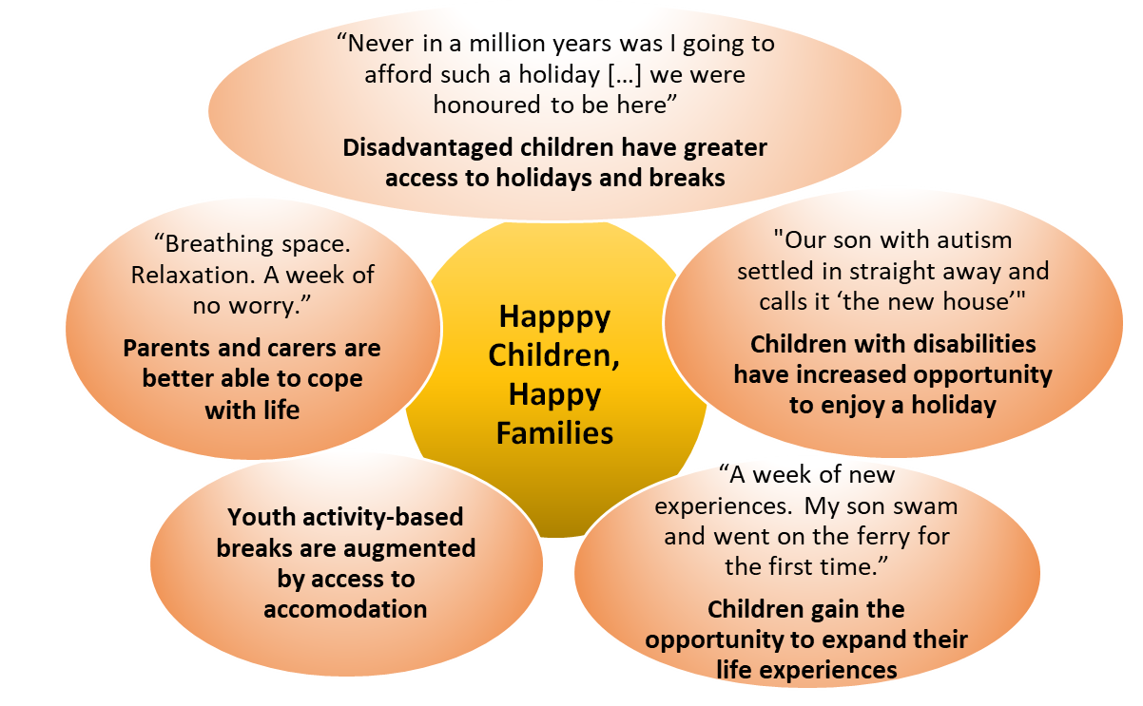

Strengthening Families - “Myself and husband and other 3 children find it hard to spend family time together but with GCHS it all changed.”

Aiding Positive Feelings - “I am so excited and tears for joy are running down my cheeks”

Broadening Experiences - “I had lots of fun and lots of adventures”

Helping Children be Active - “After holiday my children are active and happy”

Developing Social Interactions and Reducing Isolation - “I can’t believe how much [my child] shines!”

What Children and Families Said – Making Memories 2022/23

- The Holiday project is a fantastic scheme for families with not a lot of income and in need of a great holiday. I thank you sooo much for the amazing time my family and I have had and are ready to face going home knowing we have had a wonderful time. Can’t fault it in any way. Thank you once again

- Hi me and my family have just came back from your caravan and would just like to thank you from the bottom of my heart. It was a great weekend and we really needed it. What you do for all types of family’s is amazing. Thank you again

- We give this caravan 10/10. We have had an amazing time! The view is breathtaking! The staff at Reception and the cleaning staff deserve big gold stars for being friendly, approachable and rectifying any concerns immediately. We don’t want to go home and we will definitely want to come back

- We had the most amazing time at Wemyss Bay with lots to do and explore. My grandkids loved it so much and to just have the freedom to play and enjoy quality time was just amazing. You do a fantastic job in giving us the chance to experience a great holiday. To let go of the worries and the stresses of life for a week. I am truly grateful to you and may many families feel the same way I do.

- Just want to thank you guys so much, we are sad to be leaving and wish we would come back in the summer this made my boy so happy and made him so confident, was even on the stage singing.

- We have had the loveliest time. My little boy has Asperger's and was going through a really hard time before coming here. It’s helped him so much he’s loved it. Thank you for giving us this opportunity as a family we really appreciate it.

- The group holiday weekend was a powerful opportunity for the women and their children to get away from the strain of everyday life and experience the wonderful Wemyss Bay Caravan Park, in a safe, co-ordinated way. They were able to enjoy quality time together as a family and make new friends, during group activities. It has given us another tool to assist families to recover from the trauma of domestic abuse. It was exciting, enjoyable and a real healingopportunity.

- Massive thank you to the Children’s Holiday Scheme. My daughter and myself had an amazing week. My daughter smiled from start to finish. Caravan is excellent, blown away by the amount of stuff for kids to play with. Very grateful

- Thanks for having us for the week, the view is amazing and we will miss it a lot. It has been really good to get away from the flat for a bit and it gave the kids a chance to play outside. Love the fact the gate can lock, made me feel safe while they were out, Thanks for everything.

- Hi just wanted to say thank u so much my girls had a ball, wee girl is non-verbal and she was like a different kid. Thank u so much again. Made me so happy to see them so happy xxx

- Thanks very much for the week’s break, this was our granddaughter's 1st holiday and she loved it. She played with every toy you had. Your caravan is lovely, everything you needed was here. Can’t thank you enough for this holiday and would love to return here again. Thanks again.

- I have been having a hard time at school and I really enjoyed the stadium visit, it was fun and helped me to switch off for a bit. I got to chat to the staff about what I am going through. (13 year old, Day Out feedback)

Trustees Report

Directors and Trustees The Holiday Scheme is a small registered charity, operates a part-time office and is managed by a volunteer group of trustees. The Trustees who served during 2022/23 are as follows:

Dominic Young Chair and Trustee since November 2016
Hilary Gibbs Trustee since 2007 – sadly deceased March 2023
John McDougall Trustee since 2011
Anne Naismith Trustee from September 2017
Nicola Meek Trustee since January 2019 and Vice Chair since November 2021
Alan Forbes Trustee since August 2020
Elaine MacMahon Trustee from May 2021

Employees (part-time)
Douglas Wilson, Coordinator (20 hours per week)
Allison Rose Grady, Programme Officer (15 hours per week)

Patron Alex Norton

Structure, Governance and Management

Governing Document The organisation is a Scottish Charitable Incorporated Organisation (SCIO) as at March 2014 and is governed by the constitution as lodged with the Office of the Scottish Charity Regulator (OSCR) in the Scottish Charity Register (Reg. no SCO22654)

Recruitment and Appointment of Trustees The constitution allows for up to 11 volunteer committee members including the chair. New Trustees are appointed by the existing Trustees through the management committee.

Trustee Induction and Training All committee members complete Trustee declarations and are made aware of the Holiday Scheme’s policies and procedures. All Trustees and staff are members of the Protection of Vulnerable Groups (PVG) Scheme and take due account of guidance issued by OSCR to charity trustees. Our Trustee Induction Programme is kept under review and is responsive to individual Trustee’s needs in terms of their skills and experience. Trustees and staff have the opportunity to attend a range of seminars and training events through, for example, Glasgow Council for Voluntary Service (GCVS) of which we are a member, OSCR and charity Trustees seminars. A schedule of training events undertaken is held and regularly reported to committee.

Risk Management Trustees have assessed the major risks to which the Charity is exposed, in particular those relating to the operations and finances of the charity, and are satisfied that systems are in place to mitigate exposure to major risks. Our risk register is regularly reviewed and is presented to committee approximately every 6 months for review and any updates.

Our policy and procedures are reviewed regularly including our Child Protection Policy and Procedures which are assessed annually.

Related Parties The charity is not connected to any other body.

Reserves Policy Trustees seek to retain a minimum of six months free financial reserves. The purpose of which would be to allow for time to source new funding or manage the wind down of the charity while being able to meet operational costs for that period, in particular, the running costs of our 5 static caravans as well as staffing and office costs in what is a particularly challenging cost and funding environment especially post-pandemic.
In presenting our accounts for 2022/23, Trustees consider that our reserves are provided through our investment fund which, as well as ensuring the longer-term sustainability of the charity, is used to meet part of our annual operational costs that continue to increase reflecting recent high inflation and cost increases. The fund is invested in Equities and Government Stocks to produce a level of income, which the Trustees consider sufficient to respond to the charity’s costs longer term. In addition, Trustees have agreed that our minimum bank balance for general expenditure should be around £15,000.
Trustees regularly and closely monitor the charity’s income and expenditure with budget reports at every committee meeting. In terms of the Investment Fund, Trustees carefully manage the amount of withdrawals from it – in 2022/23, we agreed to draw down £1,000 per month towards our running costs and drew down £15,000 as part payment of our annual caravan costs. Our investment fund managers have discretionary management powers.
Trustees continue to keep our finances and reserves policy under review ensuring we use our resources to benefit children and families as well as ensure the longer-term sustainability of the Holiday Scheme in a challenging cost and funding environment.
Caravan valuation The estimated total trade or exchange value of our 5 static caravans is incorporated in our annual accounts. Part exchange values are generally higher than trade values. It has been our general policy to part exchange each of the caravans for newer models prior to 10 years old. We also have a general policy of undertaking internal caravan refits after 4-5 years usage. We currently own 5 static caravans, all centrally heated and double glazed and capable of accommodating groups and families of 6 to 8 people. We have a 2020 Willerby Richmond 2 bedroom adapted caravan, a 2012 Atlas Chorus 3 bedroom which was partially refitted in 2018, a 2015 ABI Oakley 3 bedroom, a 2017 ABI Trieste 3-bedroom caravan and our most recent purchase a 2021 Swift Loire 3-bedroom caravan. All are sited at Wemyss Bay Holiday Park. Our adapted caravan is wheelchair accessible and 2 other caravans have access ramps.

Financial Review
The Charity’s raised income for the year amounted to £68,753. Expenditure was £127,237 (including £19,874 in caravan depreciation). This resulted in a total deficit of £58,484 received during this financial year.

We entered the financial year with funds of £571,528 comprising £39,455 in cash at bank, £421 in petty cash, £433,120 in a charity investment fund and £98,532 in caravan fixed assets.
The closing funds at the year-end were £488,490 comprising £28,266 in cash at bank, £0 in petty cash, £381,566 in our charity investment fund and £78,658 in caravan fixed assets.

Signed...................................................................... Date ……………………….
Dominic Young, Chair

Signed....................................................................... Date ……………………….
Nicola Meek, Vice Chair

For funding and practical support during 2022/23 year we thank:

Michael and Varuni Janson | EDF Energy Helping Hands volunteer initiative and employee fund | B and I Davidson
T Bannigan and Staff at Accenture | A Woodward and Virgin Money Foundation | Awards for All (replacement ramp and balcony SV23)
All Saints Episcopal Church, Bearsden and Lunch Club and various individual members | WA Cargill Charitable Trust | Dr Guthrie’s Association (towards days out)
Reach Bank of Scotland | University of Glasgow Internship Programme | Better Scotland Football
A Caldwell | R Fraser | D Hamblen and Trades House, Glasgow
Charities Aid Foundation | Glasgow Care Foundation (towards additional caravan rental costs) | Amazon Smile
Trefoil Fund (towards adapted caravan costs) | Hugh Fraser Foundation | St Andrew’s Church, Uddingston and various individual members
OLA Football Club | Kilt Walk | ALA Green Charitable Trust
Hugh Stenhouse Foundation | St Ninian’s Episcopal Church, Pollokshields, Glasgow and several individual members | The Endrick Trust
Mrs Jane Allan’s Trust | Bellahouston Bequest Fund (towards additional caravan rental costs) | Saints and Sinners Club of Scotland
Mugdock Children’s Trust (towards days out) | St Margaret’s Church, Newlands, Glasgow and various individual members | Glasgow/Galloway Diocese Mothers’  Union
A MacLeod | E Hannah | H MacGilp
The Netherton Charitable Trust | Knightswood Congregational Church | St Andrew’s Episcopal Church, Milngavie
We also thank a number of individual supporters for their support including numerous Just Giving donations.

Volunteers and Supporters

As ever we say a huge thank you to our many volunteers and supporters, on behalf of all the children and families who have had a memorable experience this year.

Support includes:
- Fundraising initiative and events
- Volunteer days at our caravans in March, June and November to help prepare the caravans, undertake a mid-year refresh and close them down at the end of each year
- providing toys, books, games, and kitchen equipment and supplies for our caravans,
- donating to our Christmas Gift Scheme, and
- giving through private donation
The Holiday Scheme couldn’t run without you.

How to help us

Glasgow Children’s Holiday Scheme only operates through donations and grant funding. Please continue to help us to give disadvantaged children the chance to create some happy holiday memories. Holidays matter and you can help give the chance for children to enjoy a break away from the stresses of daily life, something many of us take for granted but which many children never have the chance to enjoy.

We are a small charity, but we have a big impact and provide positive change:

- £10 can provide games and toys for one of our caravans
- £50 can help pay for a family holiday
- £100 can assist a youth group to get an activity break
- £5,000 can pay for the siting and maintenance of one of our caravans for a year enabling 90 children to get a holiday. You can sponsor a caravan for between £5,000 and £10,000.

The Holiday Scheme relies on volunteers. If you can help us in any way, please get in touch. We would be delighted to hear from you.

Please donate at: www.glasgowchildrensholidayscheme.org.uk or at Just Giving – Glasgow Children’s Holiday Scheme

Contact: Douglas or Allison at:

Follow us on Twitter at @GCHS_charity | 114 - Pentagon Centre, 36 Washington St, Glasgow  G3 8AZ Tel 07512 825588 / 07515 886822  Email: admin@glasgowchildrensholidayscheme.org.uk  Website: www.glasgowchildrensholidayscheme.org.uk

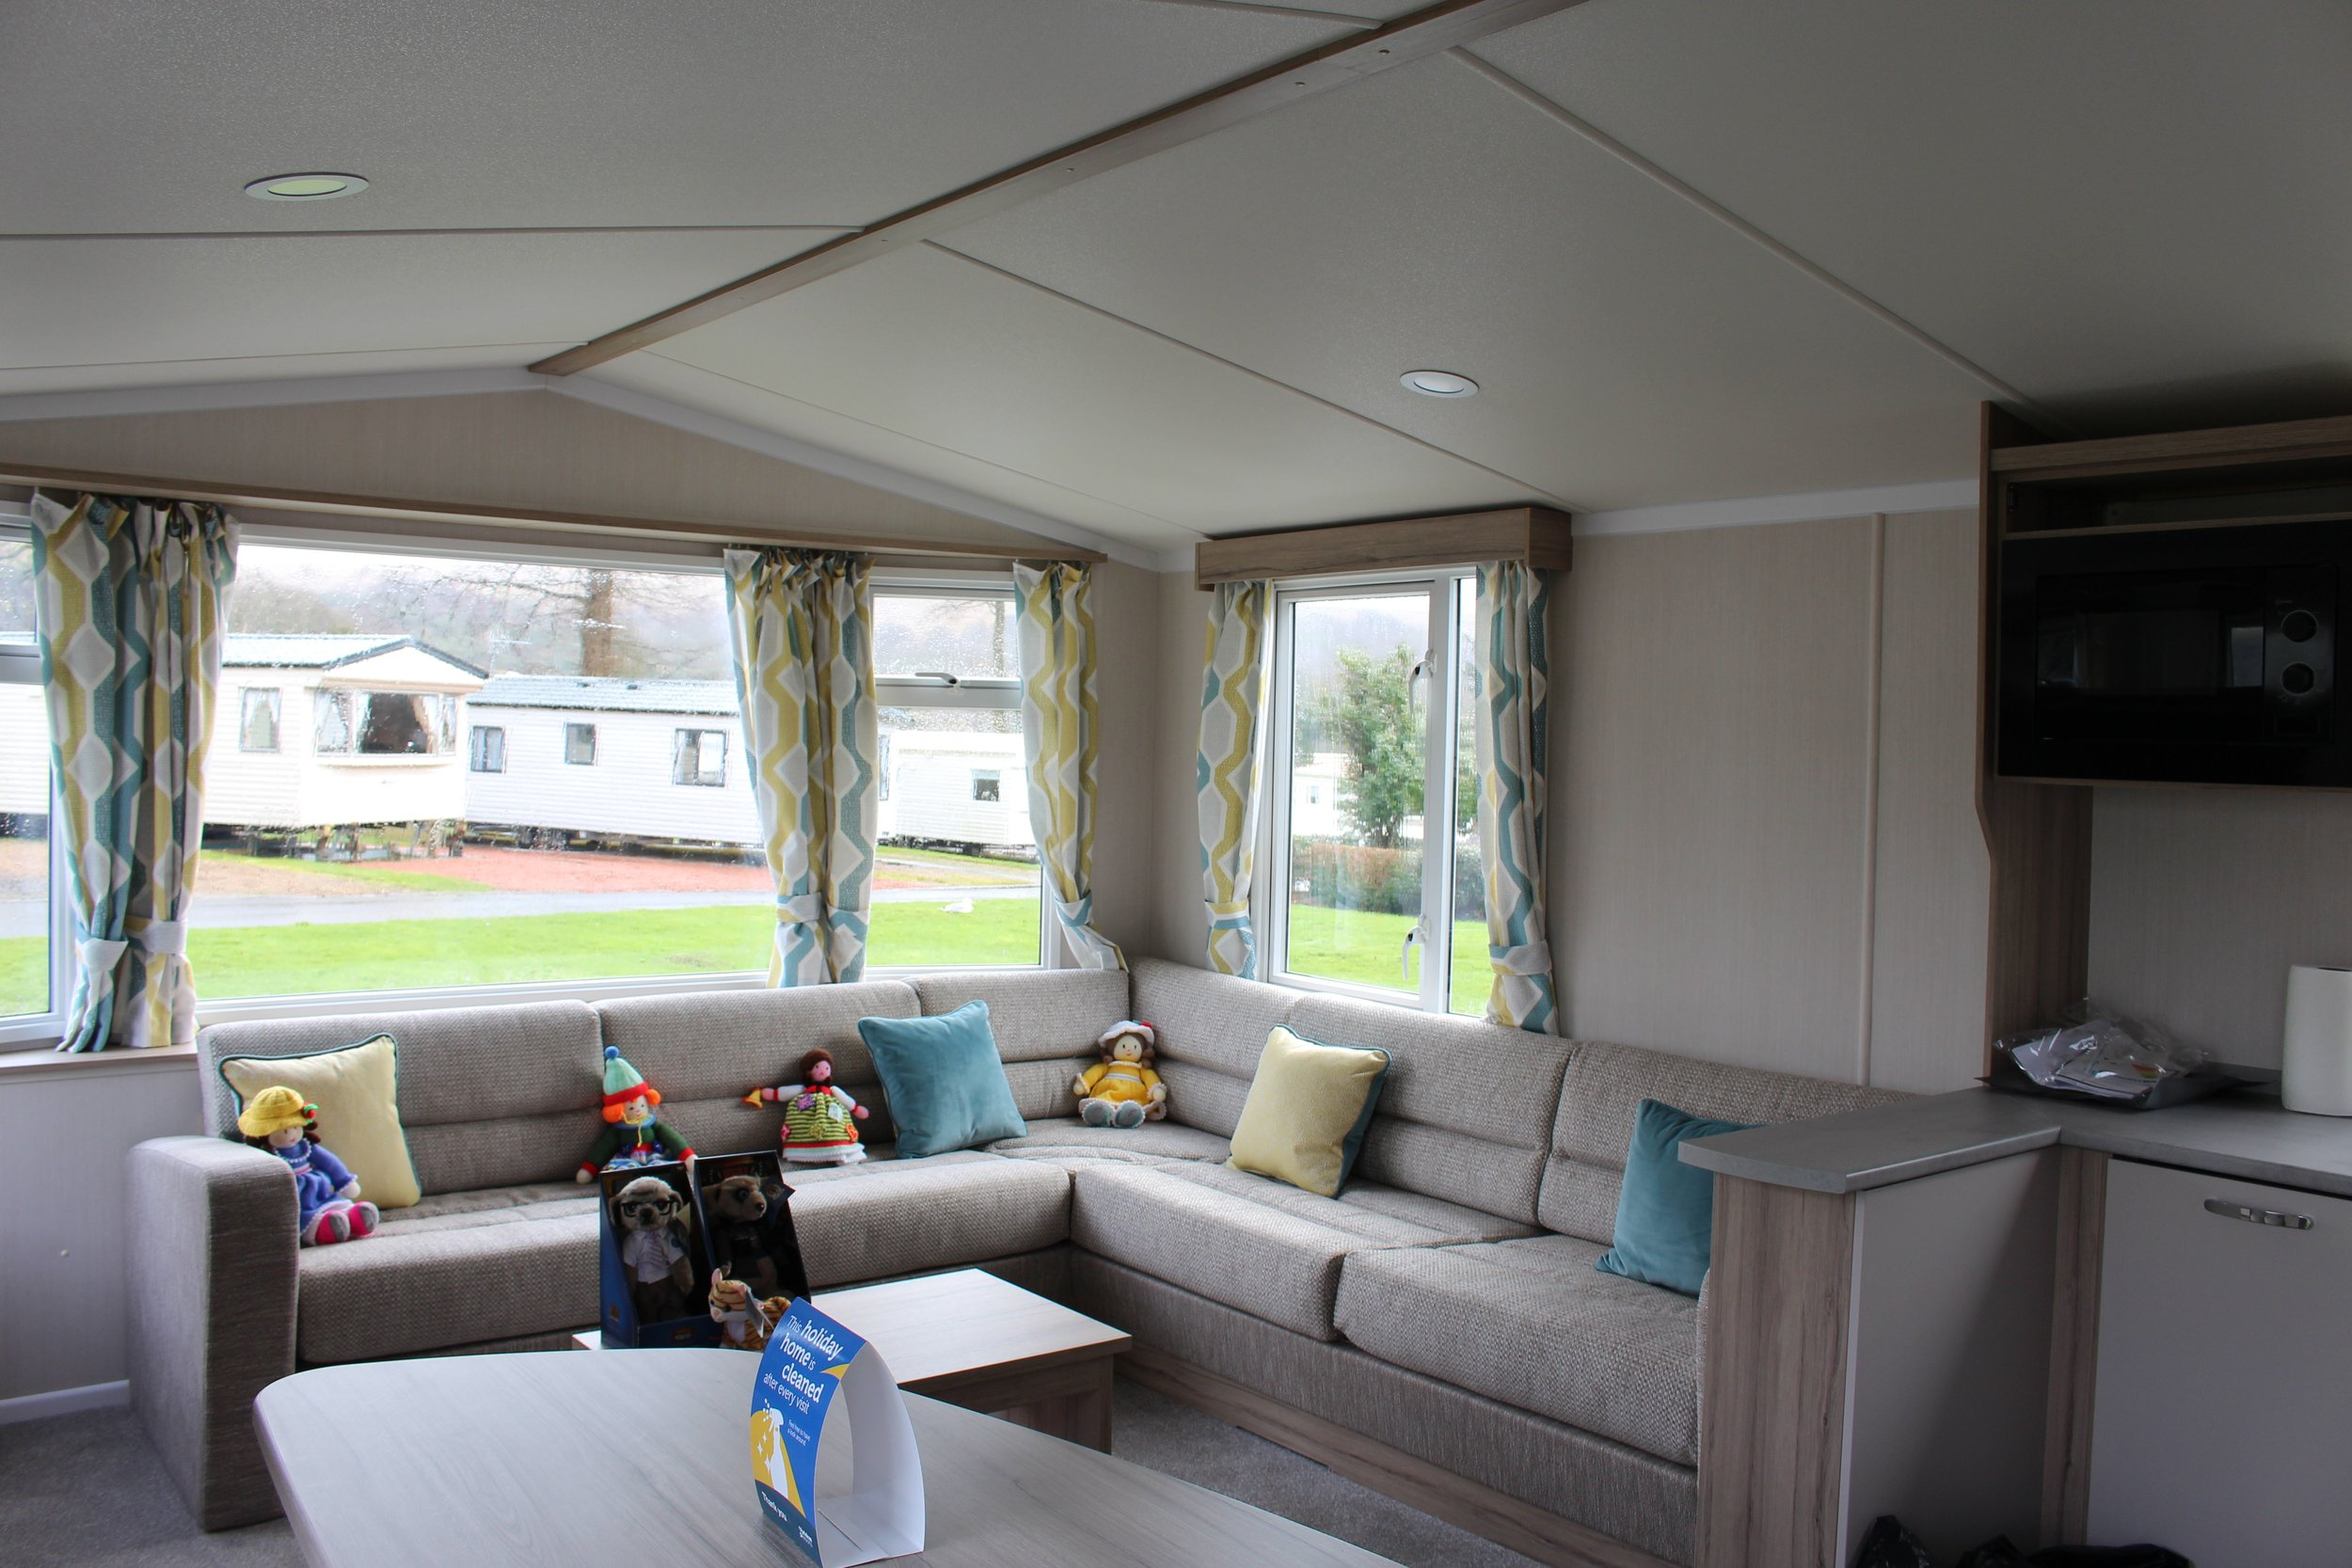
Enjoy a stay at our well-equipped caravans….and enjoy the views...

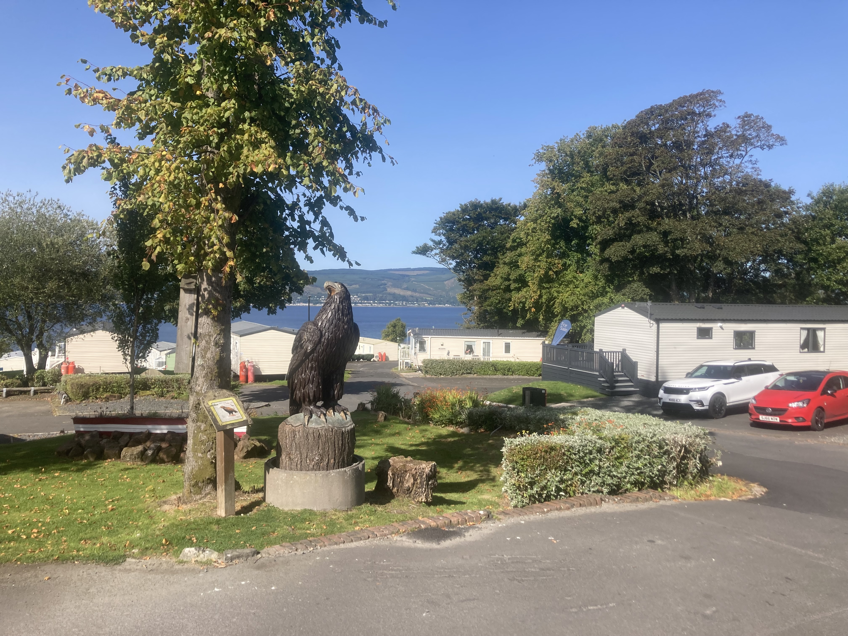

Have fun on Park, at the entertainment and at the Pool

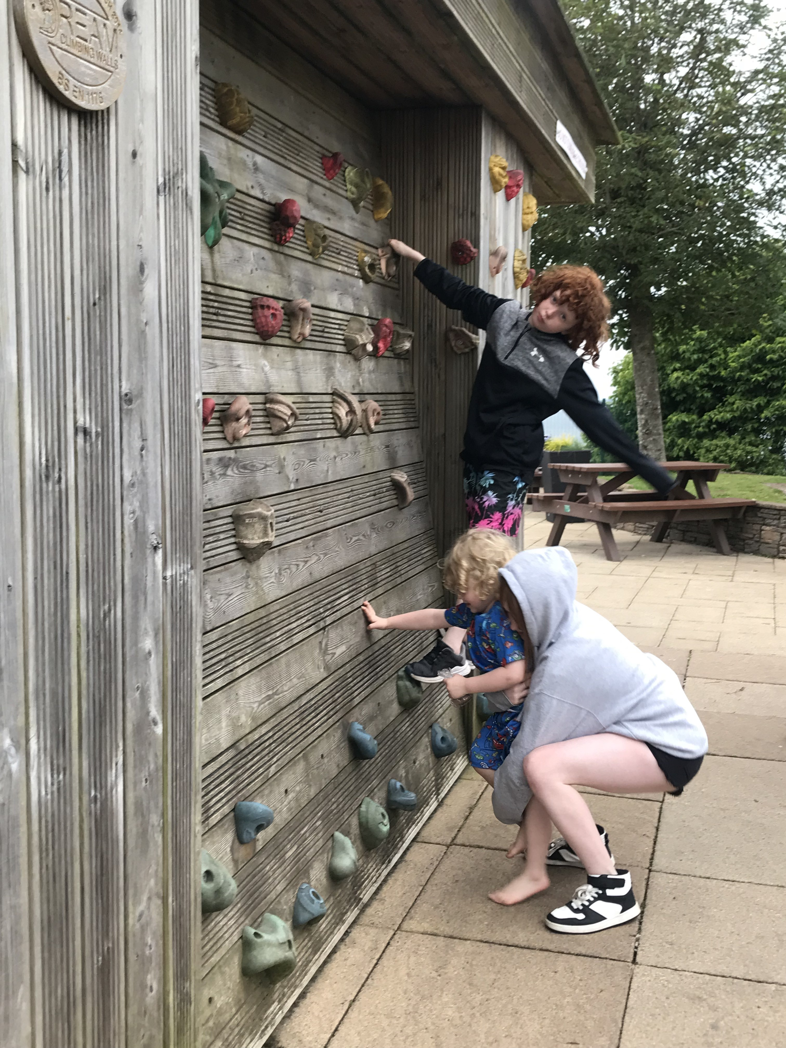
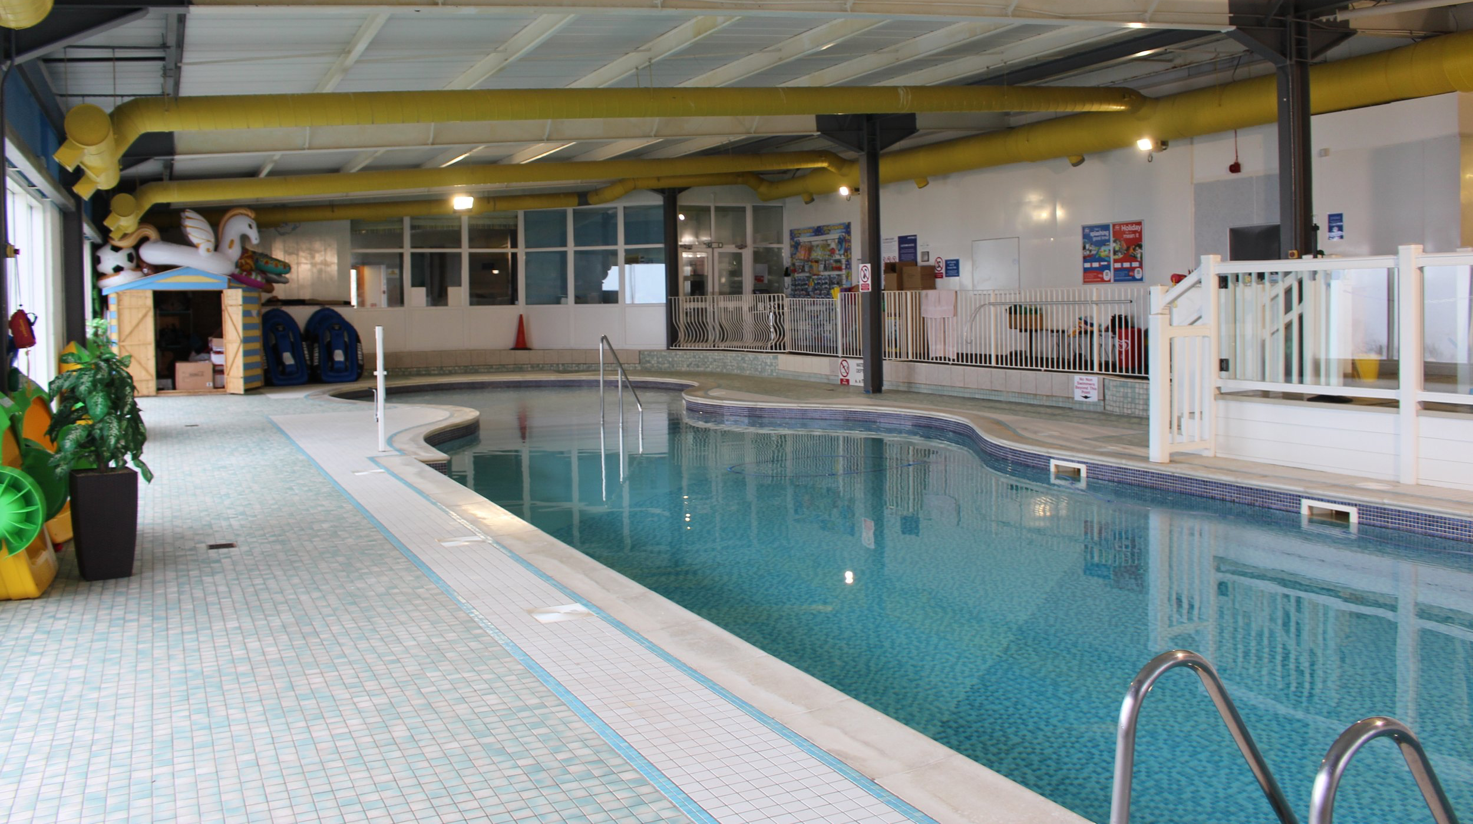
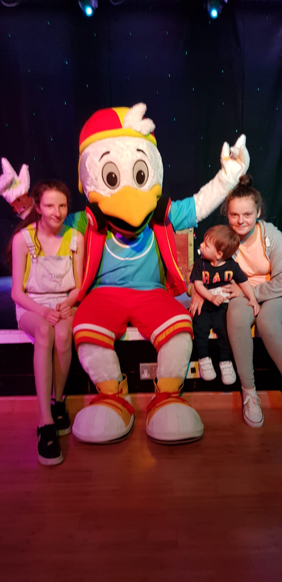
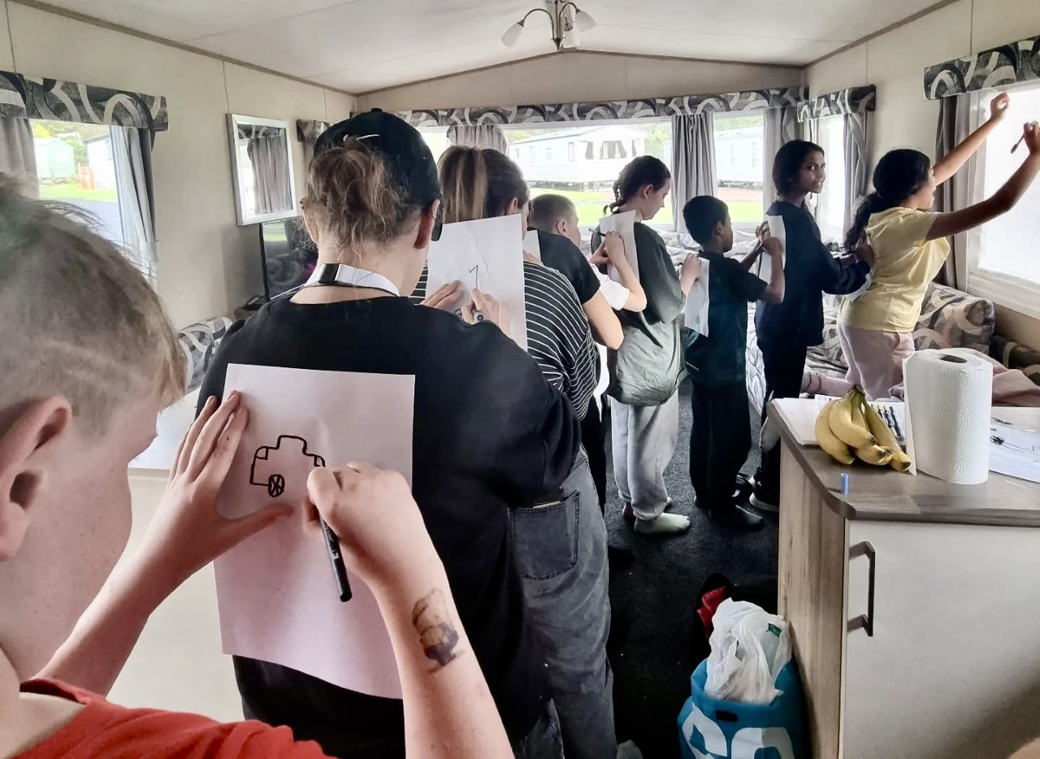

MAKING MEMORIES WITH

www.glasgowchildrensholidayscheme.org.uk
Twitter: @GCHS_charity
Facebook: Glasgow Children’s Holiday Scheme
You Tube: Glasgow Children's Holiday Scheme

