Glasgow Children’s Holiday Scheme

Impact Report of Holidays and Breaks on
Children and Families

Prepared by Dora Moldovan, University of Glasgow Intern

April 2021

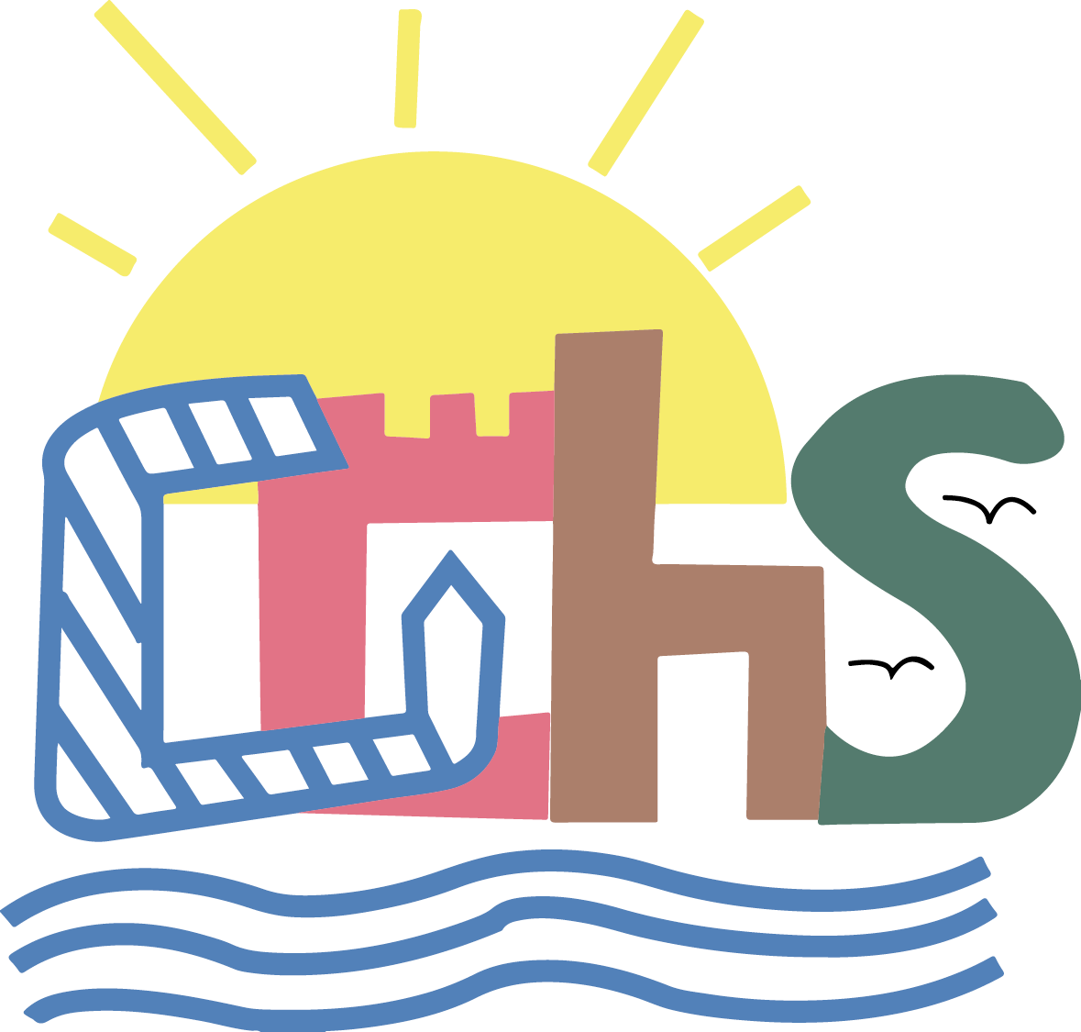

Contents Page

- Glasgow Children’s Holiday Scheme 3
- Child Poverty in Context 6
- The Impact of Holidays and Breaks through GCHS 8
- Case Studies 11
  - “Amy’s Story”
  - “Angela and Liam’s story”
  - “Farzana’s story”
  - “Richard’s Story”
- Conclusion 15

Glasgow Children’s Holiday Scheme

For over 60 years, Glasgow Children’s Holiday Scheme (GCHS, the Charity) has been offering holidays for thousands of disadvantaged children and their families. Providing children and families with the breaks they need but otherwise would not get for reasons of disadvantage such as poverty, deprivation, ill health, disability or other adverse circumstances including bereavement, mental health problems or domestic abuse. In any given year, the Charity is able to support over 200 families and over 500 children and young people, including around 100 children with a disability. This includes a range of families including kinship carers, families affected by domestic violence, young carers, support carers and single parents. The charity is oversubscribed by applications each year, in particular, for the school holiday periods.

Principles:

What does Glasgow Children’s Holiday Scheme Offer?

Caravan Holidays

The Charity own 5 static caravans (including an adapted caravan) at Wemyss Bay Holiday Park on the Clyde Coast, through which short breaks or one-week holidays are offered. During the holiday, families can enjoy indoor swimming, sauna, amusement arcade and pool tables, along with outside spaces such as a playground and a climbing wall. Children also have the chance to learn about the local wildlife or about regional history by visiting for example the nearby Isle of Bute or the Vikingar in Largs. Direct holiday costs are kept to be as low as possible for families, charging only £20-£40 depending on the length of the break – or no amount, should circumstances necessitate. This charge, while kept under review, allows the Charity to partly cover weekly cleaning and changeover costs. Glasgow Children’s Holiday Scheme is focused on keeping direct costs low.

Activity Based Breaks
Glasgow Children’s Holiday Scheme provides the opportunity for youth organisations to use the caravans as a base for outdoor activity breaks for groups of young people, organised and supervised by their youth leaders. There is focus on group activities, outdoor opportunities and the chance to build positive relationships. Through these local youth organisations young people get to enjoy outdoor activity and time away from home helping to build effective relationships. The Charity has in recent years also supported holiday football camps enabling children to access free football. This has been achieved in partnership with OLA Football Club and further developments are planned. In addition, the Charity is looking to develop support for family days out and other activity related opportunities.

Host Family Holidays

Young people have the opportunity to benefit from a holiday with a volunteer host family. They enjoy new experiences, broaden their horizons, gain confidence and, for some, have a break from a caring role at home. Many of the children return over a number of years forging strong supportive bonds and positive relationships.

Christmas Gift Scheme
The Holiday Scheme also operates an annual Christmas gift scheme providing gifts and support to children and families who need additional support around Christmas.

Support during COVID-19
Although the COVID-19 pandemic limited the Charity’s prospect of providing the usual services, Glasgow Children’s Holiday Scheme continued to support children and families in need through various other avenues by supporting a number of organisations, for example, with the Refuweegee Project, Royston Youth Action and Church House, Bridgeton to offer donations and financial support for games, toys and outdoor equipment, or supporting the Daisy Project and Glasgow Women’s Aid with vouchers.

Child Poverty in Context

Statistics

It is estimated that across Scotland, after housing costs, around 24% of children live in poverty in 2019 with 31.8% (31823) of those children living in Glasgow City. This is a 4.8% rise from measures taken in 2015.

In Glasgow City:

47.3% of Glasgow residents reside in the 20% of most deprived areas in Scotland

18% of households cannot manage well financially.

24% of dependent children live in a household where at least one parent is disabled.

The Policy Context

The Tackling Child Poverty Delivery Plan 2018-2022 was introduced to focus on 5 key areas:
- Work and earnings
- Costs of living
- Social security
- Helping families in other ways
- Partnership working
The Child Poverty Scotland Act (2017) set out, that, by 2030,
- Fewer than 10% of children living in families should be in relative poverty
- Fewer than 5% of children living in families should be in absolute poverty
- Fewer than 5% of children living in families should be living in combined low income and material deprivation
- Fewer than 5% of children living in families should be in persistent poverty

Lived Experiences

Several studies (see below) have highlighted that children from poorer backgrounds experience severe disadvantages which have long-term negative effects on their lives. One of such disadvantages is the inability to experience a holiday break and the benefits it has to offer in the development of children and to their families. As a consequence of financial difficulties, parents living in adverse circumstances are unable to provide holiday activities which results in negative effects on children’s wellbeing and mental health.

For example, there is a significantly higher risk for children from poorer backgrounds to feel lonely and isolated during the school holiday (Mann et al., 2018 and Morgan et al., 2015). Furthermore, such exclusion often results in a sedentary lifestyle for children, which affects their physical wellbeing as well (Stewart et al., 2018). In addition to the negative effects on mental and physical wellbeing, being excluded from experiences which are a part of society’s norms (such as taking a holiday) also bring on a feeling of shame and being disadvantaged, increasing social ills and rejection (Sedgley et al., 2012). To sum it up, a 2004 (Hazel) study revealed that holidays have important social and medical benefits for families living in adverse circumstances, as such breaks offer:
- Relief and renewal
- Improved mental health
- Opportunities for social interactions
- Widening experiences
- Developing independence
- Strengthening family relationships

The Impact of Holidays and Breaks through GCHS

This section of the report presents the themes (with examples) that emerged during a thematic analysis of the feedback gathered from children and parents/carers who enjoyed a holiday or a break through the Glasgow Children’s Holiday Scheme and from referrers who referred families and children to the Charity during the years preceding the COVID-19 pandemic.

Feedback gathering utilised written and verbal approaches as well. Interviews were conducted with parents and children, and with participants of the youth group projects. Written feedback from children and families was gathered through questionnaires and through the (very) popular notepad located in the caravans in Wemyss Bay, whereas referrers and youth group leaders also provided their views through surveys.

Five main impacts of GCHS holidays and breaks were identified in respondents’ lives:
- The opportunity to strengthen families
- The potential to aid positive feelings
- The means to broaden experiences
- The capacity to help children be active
- The ability to develop social interactions and to reduce isolation.

Strengthening Families

“Myself and husband and other 3 children find it hard to spend family time together but with GCHS it all changed.”

Feedback from families and children highlighted how, often for the first time in their lives, they had the opportunity to get a break and to spend quality time together away from their home environment. The chance to relax in the caravans, play outside or explore the surrounding area. Most families expressed that, due to their “every day stresses and struggles”, they had little if any time before the holiday to enjoy time together and build their relationships within their respective families.

Aiding Positive Feelings

“I am so excited and tears for joy are running down my cheeks”

Every family highlighted the myriad positive impacts their holiday brought to them – both to the children and to their parents or carers. Children told us they felt happy, energised and more confident as a result of their holiday at Wemyss Bay. Parents also expressed that they feel a huge difference in themselves as they are better able to cope with their everyday lives and that, for a while, first time in a long time, they felt stress free, carefree and content.

Broadening Experiences

“I had lots of fun and lots of adventures”

Through their holidays, children and young people had the opportunity to participate in new activities never experienced before and to form memories which they will be happy to remember. In a safe environment, children are able to play outside, to explore and for many it can be their first chance to get to swim. Feedback tells us families just enjoy having time away together, to relax and play games; to eat out or try something new, to enjoy the seaside and of course…..enjoy an ice cream!

Helping Children being Active

“After holiday my children are active and happy”

By providing a safe space, through their holiday scheme, GCHS not only supported children to be able to play outside and enjoy the fresh air and the freedom of running in a big park, but also provided children with other activities supporting their physical wellbeing. Children, amongst other things, learnt how to swim, had the opportunity to collect shells on the sea side and go on the ferry for the first time. These activities had a positive effect on both physical and mental wellbeing, influencing children’s behaviour and welfare beyond their holiday at Wemyss Bay.

Developing Social Interactions and Reducing Isolation

“I can’t believe how much [my child] shines!”

Holidays and activity breaks supported children to engage in social interactions and therefore to reduce their isolation experienced as a result of their adverse life circumstances. Children reported that they made new friends during their holidays and often played together during their stay. These interactions supported children to feel part of the community and develop their interpersonal skills as well.

Case Studies
“
I have 3 boys and 2 of them are on the autism spectrum. My eldest has Asperger’s syndrome and my six year old, sadly, had a very serious regression when he was two years old and lost all his language and his ability to understand and communicate with us. Since then our life has been a whirlwind of damage limitation, coping strategies, therapies, hospital appointments and stress. Our boy is an amazing wee person and I consider myself a very lucky mum but the stress from his behaviours has been monumental for me and my older boys.

This year especially has been so hard for us, we have been struggling to cope and felt like we were being let down by everyone who was meant to be supporting us and then we were offered a holiday by your scheme. It was like a sudden ray of light in amongst all the chaos. All of a sudden someone was looking after us, taking care of us with this lovely, kind and generous offer of a break, in a gorgeous big caravan with some of the loveliest views we have ever seen! We went on lovely walks, we had ice cream and chips in Largs. We took the wee boy swimming which he loved and the big boys went to the entertainment every night to ‘chat’ to girls and got some hilarious and savage knock backs.

It was an amazing break, we had a fantastic and restful time and even found out that we’re pure geeks and love a jigsaw! We can’t thank you enough for looking after us and giving us the gift of this holiday. It has meant the world of difference to our wee exhausted gang. We feel looked after and rested and far more able to cope with our difficult times.

We are so grateful for and will never forget your kindness.

Amy and the boys
”

“
Me and my son would just like to say a big thanks to yourself at GCHS, this has been absolutely amazing as he just lost his dad at Easter this year and before all the uplifts we have both have went through from 2012 with being homeless and having to settle down in so many short-term flats ‘till we eventually got our house in 2015, this has been our first holiday away. My son is now 9 years old and he has had an amazing time meeting new friends and engaging with so many clubs, swimming, horses. The Venue he has never been away from made a huge difference in his confidence. I can’t believe how much he shines. He has changed so much with being so cheeky, and funny - loving every moment we have spent here! He just wouldn’t want to leave as it’s been so great a place. Everyone has been so nice.

We thank you from the bottom of our hearts and just hope one day we can come back as its made a huge difference in myself and my son.

Thank you,

Angela and Liam

”

“
It’s me, my husband and 3 children. My eldest has autism. Whenever we do something as a family, we need to put him into perspective to see what he likes and if the whole family would like it as well. That’s why I thought that the caravan holiday would be good for him because it is away from the city life, a rural place away from the hustle and bustle as my son doesn’t like noise and all that kind of stuff. It was good that we went because obviously with them out of school and my husband got diagnosed with [illness] last year. So, to get away from all that kind of stuff we needed something. It was something to look forward for the children and everyone was really excited that we were going away somewhere, especially the children.

On Friday we just watched television and everybody was comfortable. Especially my eldest son. He just loved being in the caravan. He didn’t want to leave the caravan. Saturday morning we went boating. [The children] really enjoyed it. This was their first boat ride in this country. We spent the whole evening at the beach. We built sandcastles and all that kind of stuff and we would stay until sunset. My eldest one was throwing rocks into the water and I was clicking away pictures. On Sunday we went to a small rocky beach. My kids were playing on the beach, throwing stones into the water. There was a small picnic table and we had our picnic there. Then we went back home [the caravan] and had lunch, then late afternoon we went swimming. After the holiday ended, [my children] continued swimming [in the local swimming pool]. On Sunday, after lunch, my husband took us to the town. We went on a wee stroll as I’ve never been there. That was a great experience. We had a takeaway as well.

When we got home, the kids were all happy. We were more worried for my eldest son, but he seems to have enjoyed it. He was the one who enjoyed it the most. When we are looking at pictures [now], he is pointing at the pictures saying that we need to go back. It was good to get away. We did everything together as a family.

Farzana and family
”

“
We love Wemyss Bay. Love the caravan, the park, love the people and the kids just have a great-great time. They love going to Wemyss Bay. You can do a lot more together.

Our son is in a wheelchair. The Children’s Holiday Scheme is so good with that! They get the wheelchair friendly caravan for us. Our son doesn’t eat, he gets fed artificial nutrition. With going to the caravan park, our local supplier delivered a fridge to the park and the park keeps it year-to-year for us. When we go, they just put it into the caravan, which is absolutely amazing. Our son just absolutely loves it [Wemyss Bay]. He has been practicing party dances already [just now] for when we are going – he is always asking when are we going because obviously we missed out last year. I think the other thing is, that it is quite handy for us. It’s not too far away, but it is far away enough to be on holiday. And it’s close to the hospital, which is really important for us in case our son becomes unwell. Our son likes to participate in everything. We usually get up in the morning, have breakfast and go down to the venue where our son takes part in whatever is going on. Then we chill in the afternoon or go to the nearby towns, or go on the ferry. Sometimes we just like to go for a walk in the park – it’s great to go for a walk around the park. At night-time, as our son is a wee guy who loves to be in the middle of everything, he loves to go down for the kiddies club and he’s up dancing and stuff like that. We usually stay down there for a wee bit and then go home [the caravan]. In the afternoon we usually play games, play cards, board games and stuff like that. It’s just relaxing. I think it’s important, it’s the time to take away the worries. He enjoys everything. Over the years, he made quite a few friends who own a caravan and are there when we are there.

Our son loves to take part in everything and when we come home, he’s just constantly playing the tunes and party dances. So, this feeling lasts quite a few weeks because he is very.. he likes doing that kind of thing. We always have a brilliant time. It is a good proper nice family holiday where you can all chill together and sit and relax and have a conversation.

Richard and family
”

Conclusion

This report evidenced the positive impacts the Glasgow Children’s Holiday Scheme has on children (and their families) experiencing adverse circumstances. As it was shown, the Charity, through its work in providing family and host holidays and activity breaks

- Strengthens Families
- Aids Positive Feelings
- Broadens Experiences
- Helps Children be Active
- Supports the Development of Social Interactions between Children and Reduces Isolation
- Enables Children and Families to Have Fun!

These positive outcomes do not cease when the holidays are over. As shown through feedback, children and their families continue to benefit from better physical, mental and emotional wellbeing long after their stay is over. This not only demonstrates that holidays and breaks are essential in the positive development of children, young people and for their families but it also shows the importance of the Charity in enhancing the wellbeing of children experiencing disadvantage.

Let’s keep making memories
www.glasgowchildrensholidayscheme.org.uk
Twitter @GCHS_charity

Hirsch, Donald and Stone, Juliet. 2020. Local indicators of child poverty after housing costs, 2018/2019. End Child Poverty. Available from: http://www.endchildpoverty.org.uk/child-poverty-in-your-area-201415-201819/. End Child Poverty. 2020. Media Release. Available from: www.endchildpoverty.org.uk/child-poverty-in-your-area-201415-201819/.
The Glasgow Indicators Project. 2021. Poverty Indicators. Understanding Glasgow. Available from: https://www.understandingglasgow.com/indicators/children/poverty/overview.
Scottish Government. 2018. ‘Every Child, Every Chance’ The Tackling Child Poverty Delivery Plan 2018-2022. Available from: https://www.gov.scot/binaries/content/documents/govscot/publications/impact-assessment/2018/03/tackling-child-poverty-delivery-plan-2018-22-annex-3-equality/documents/00533633-pdf/00533633-pdf/govscot%3Adocument/00533633.pdf. Scottish Government. 2017. Child Poverty (Scotland) Act 2017. Available from: https://www.legislation.gov.uk/asp/2017/6/contents/enacted.
Mann, Emily; Long, Michael, A.;. Stretesky, Paul, B. and Defeyter, Margaret, Anne. 2018. A question of justice: are holiday clubs serving the most deprived communities in England?. Local Environment. 23(10), pp. 1008-1022. Available from: https://doi.org/10.1080/13549839.2018.1518415.
Morgan, Nigel; Pritchard, Annette and Sedgley, Diane. 2015. Social tourism and well-being in later life. Annals of Tourism Research. 52, pp. 1-15. Available from: http://dx.doi.org/10.1016/j.annals.2015.02.015.
Stewart, Hilary; Watson, Nick and Campbell, Mhairi. 2018. The cost of school holidays for children from low income families. Childhood. 25(4), pp. 516-529. Available from: https://doi.org/10.1177/0907568218779130.
Sedgley, Diane; Pritchard, Annette and Morgan, Nigel. 2012. ‘Tourism poverty’ in affluent societies: Voices from inner-city London. Tourism Management. 33, pp. 951-960. Available from: https://doi.org/doi:10.1016/j.tourman.2011.10.001.
Hazel, Neal. 2004. Holidays for Children and Families in Need: An Exploration of the Research and Policy Context for Social Tourism in the UK. Children and Society. 19, pp. 225-236. Available from: https://doi.org/10.1002/chi.838. Report prepared by Dora Moldovan, Intern, University of Glasgow for Glasgow Children’s Holiday Scheme April 2021

